DROIDS WORKSHOPS
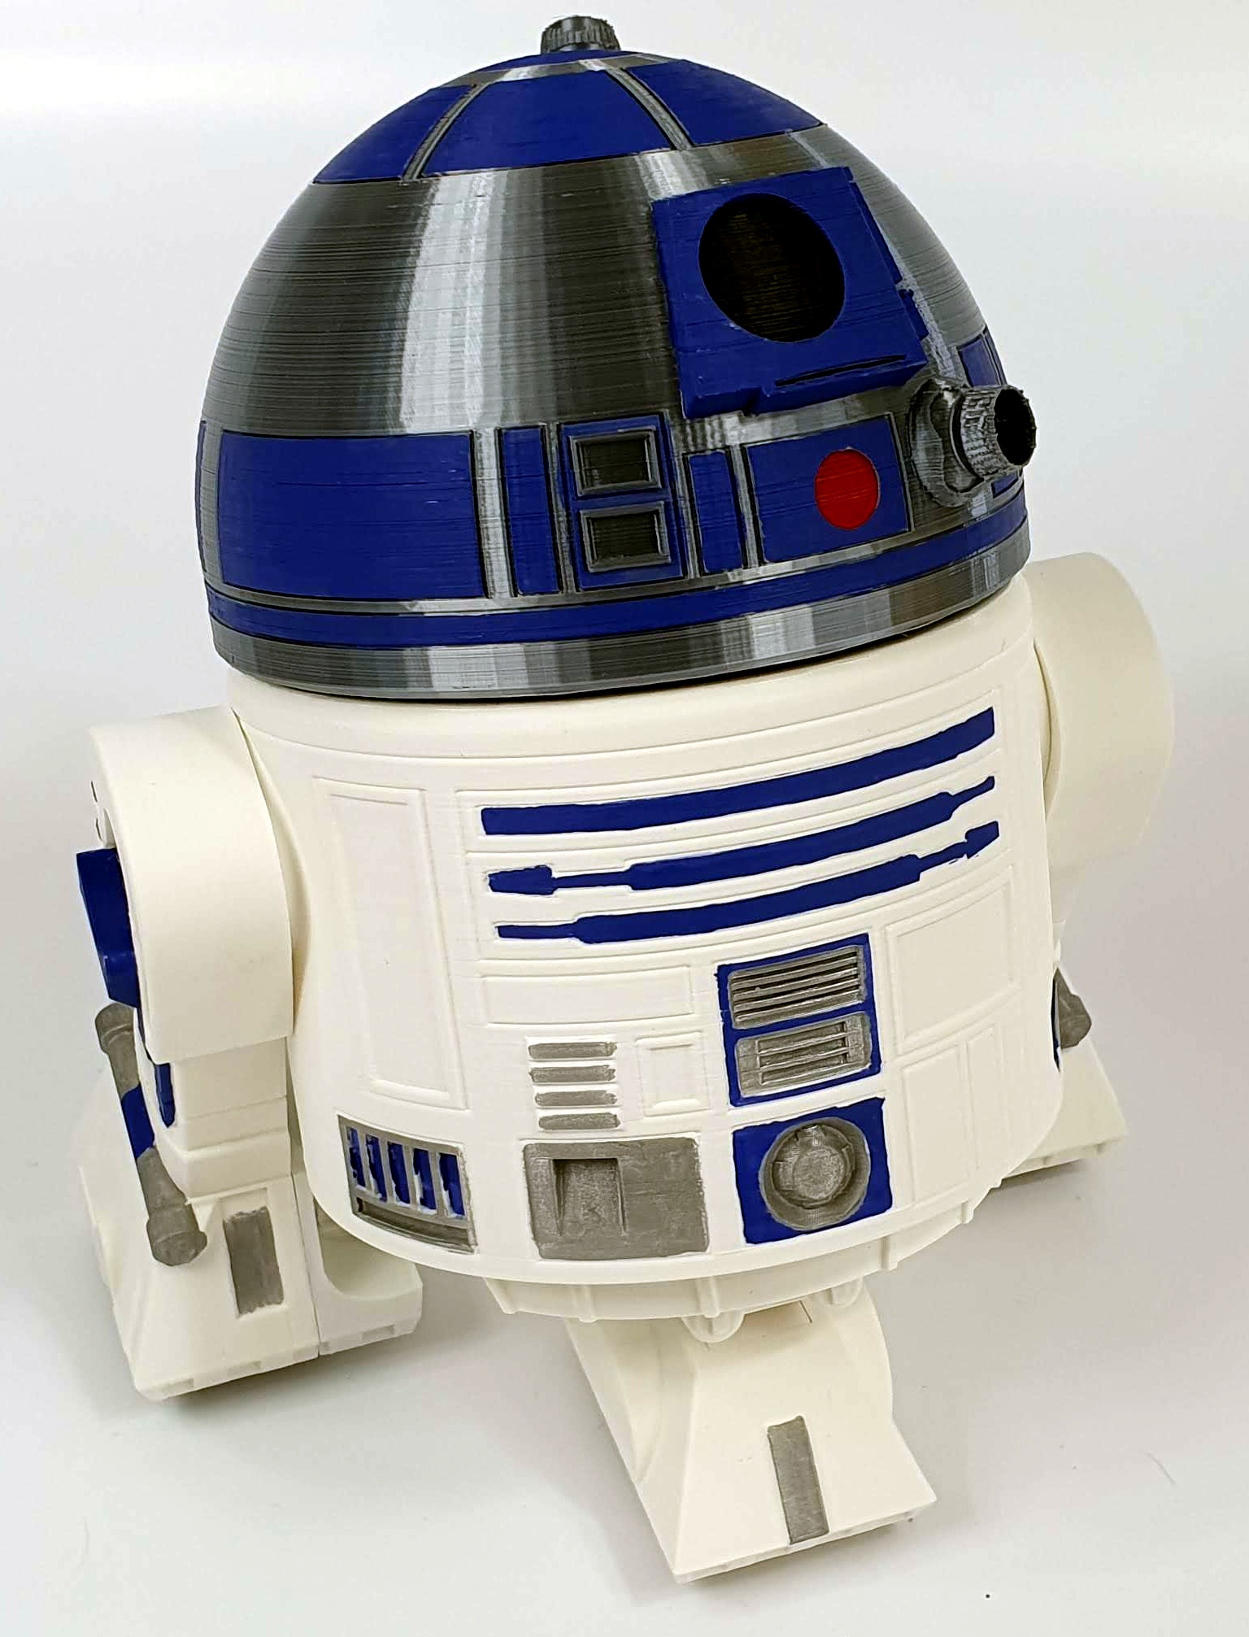

BABY DROIDS

serie R
(R2, R4, R5, R9
BT1, RBB9)

SET PARTS

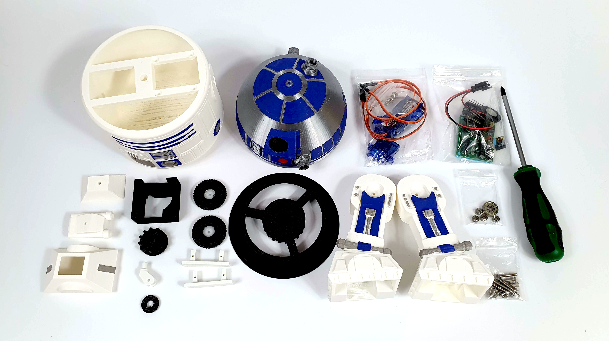
CAUTION !!!

The set includes two types of screws:
- M3 screws placed in the bag with a description of their length. To screw them in, use a larger screwdriver marked PH1x100,

- screws for mounting the servos placed in the bag together with the servos, marked in the manual as A and B. To screw them in, use a smaller screwdriver marked as PH0x75.
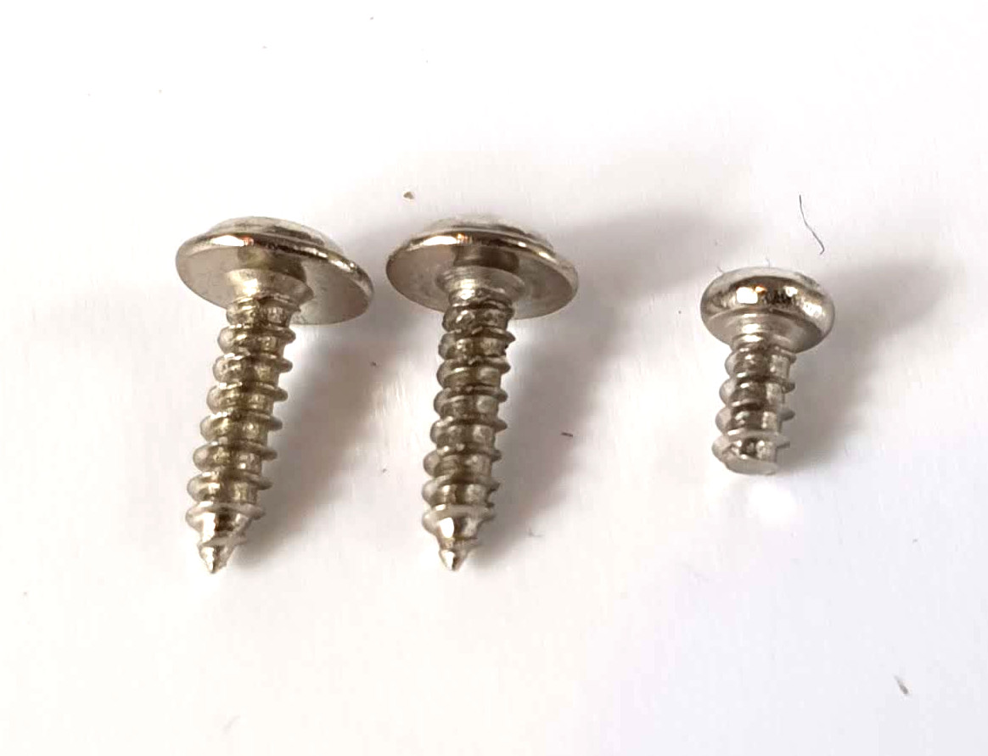
A B

FOLDING LEGS (left leg)

Screw the servo to the mounting element as shown in the photo using screws A.

Pay attention to the position of the servo in relation to the mounting (cutout marked with a red arrow).

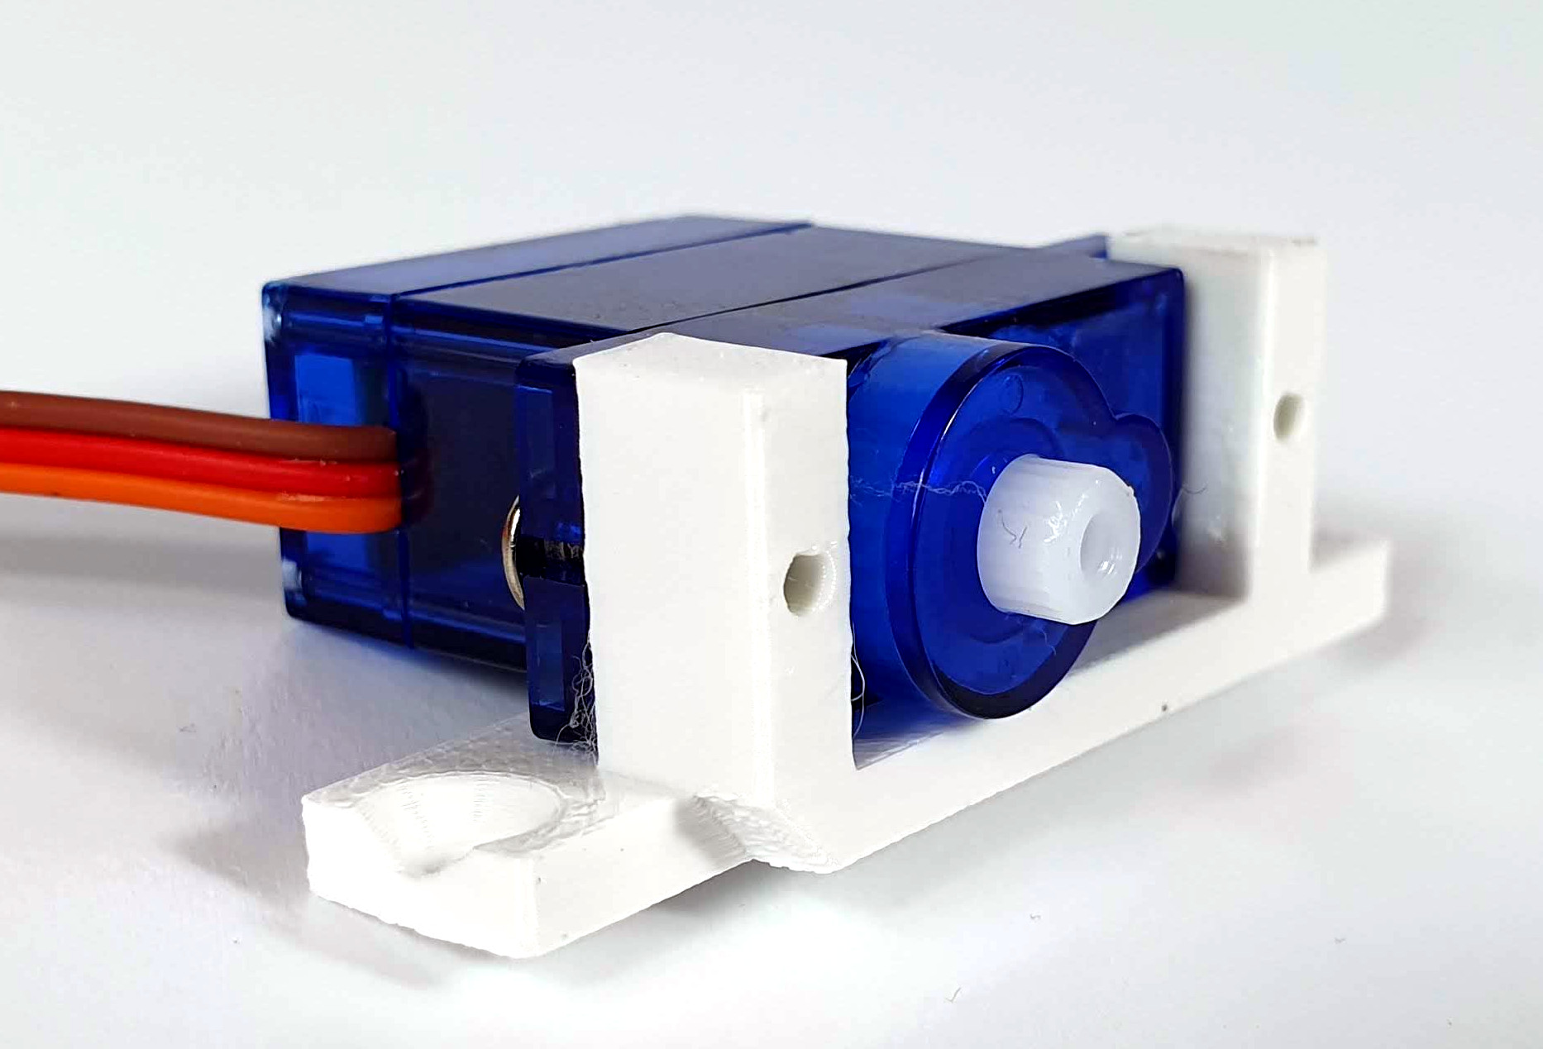

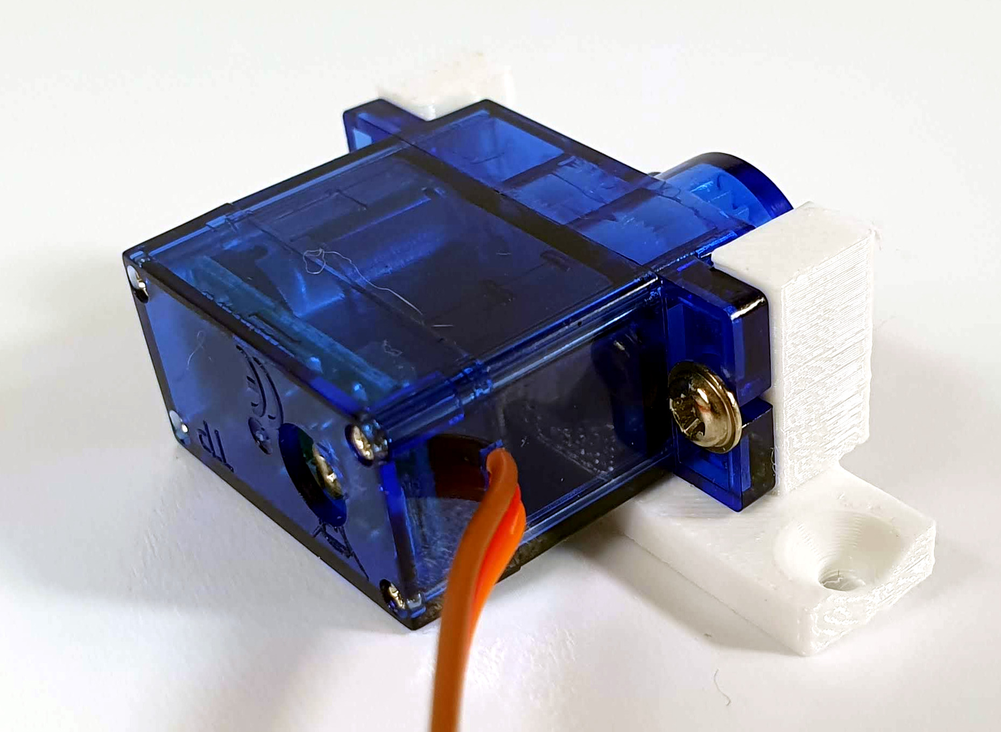
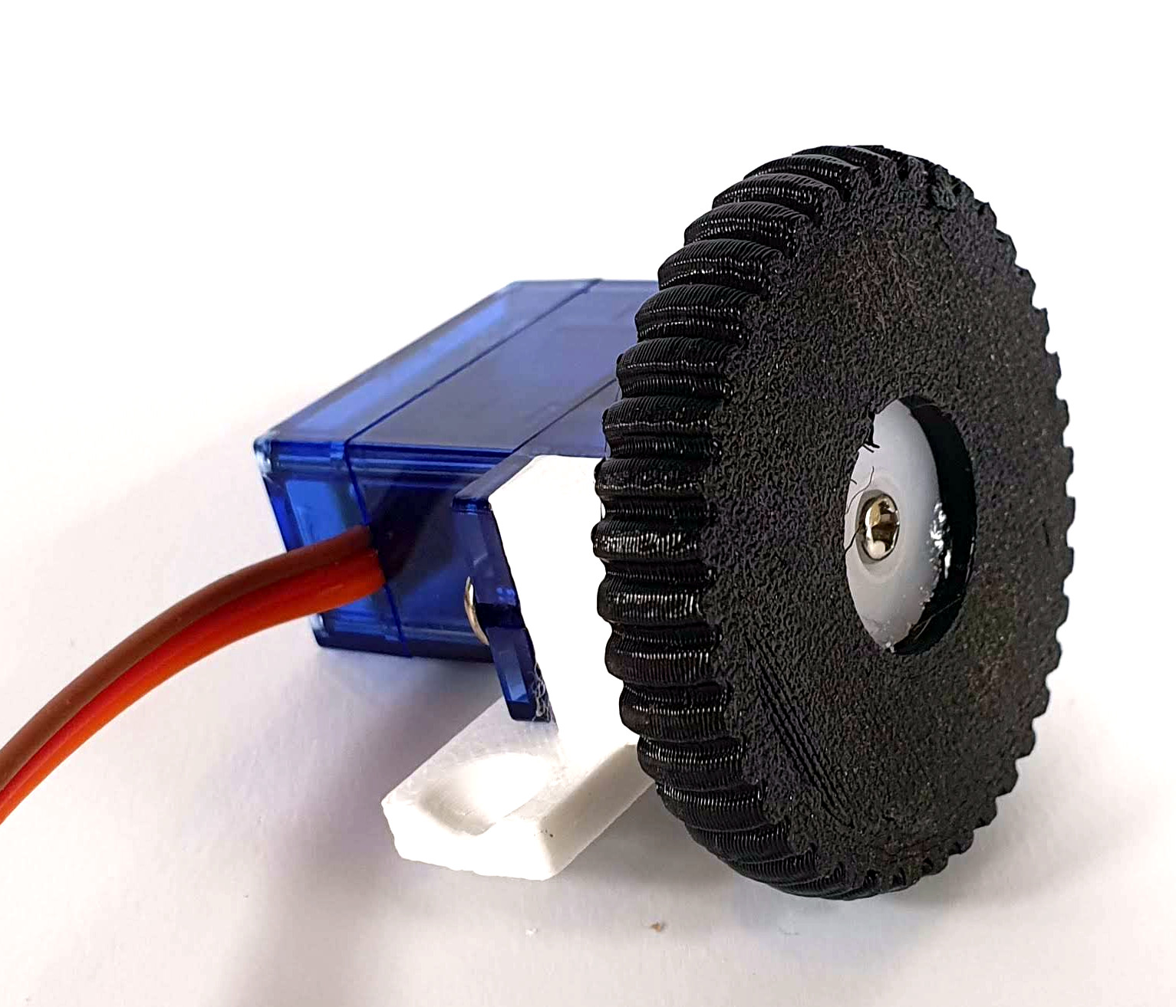
Screw the large wheel to the servo using screw B.

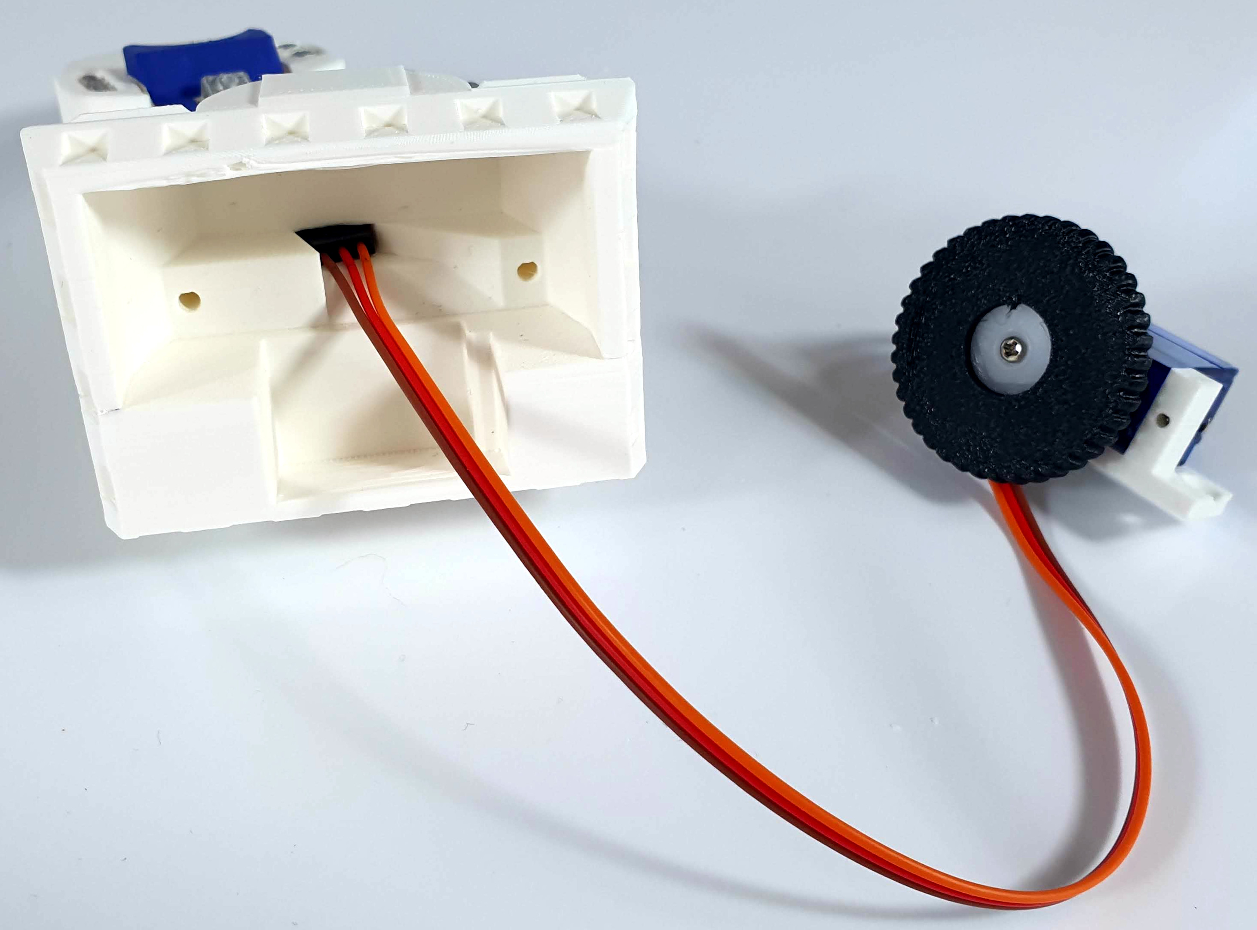
Feed the servo cable through the channel in the leg.
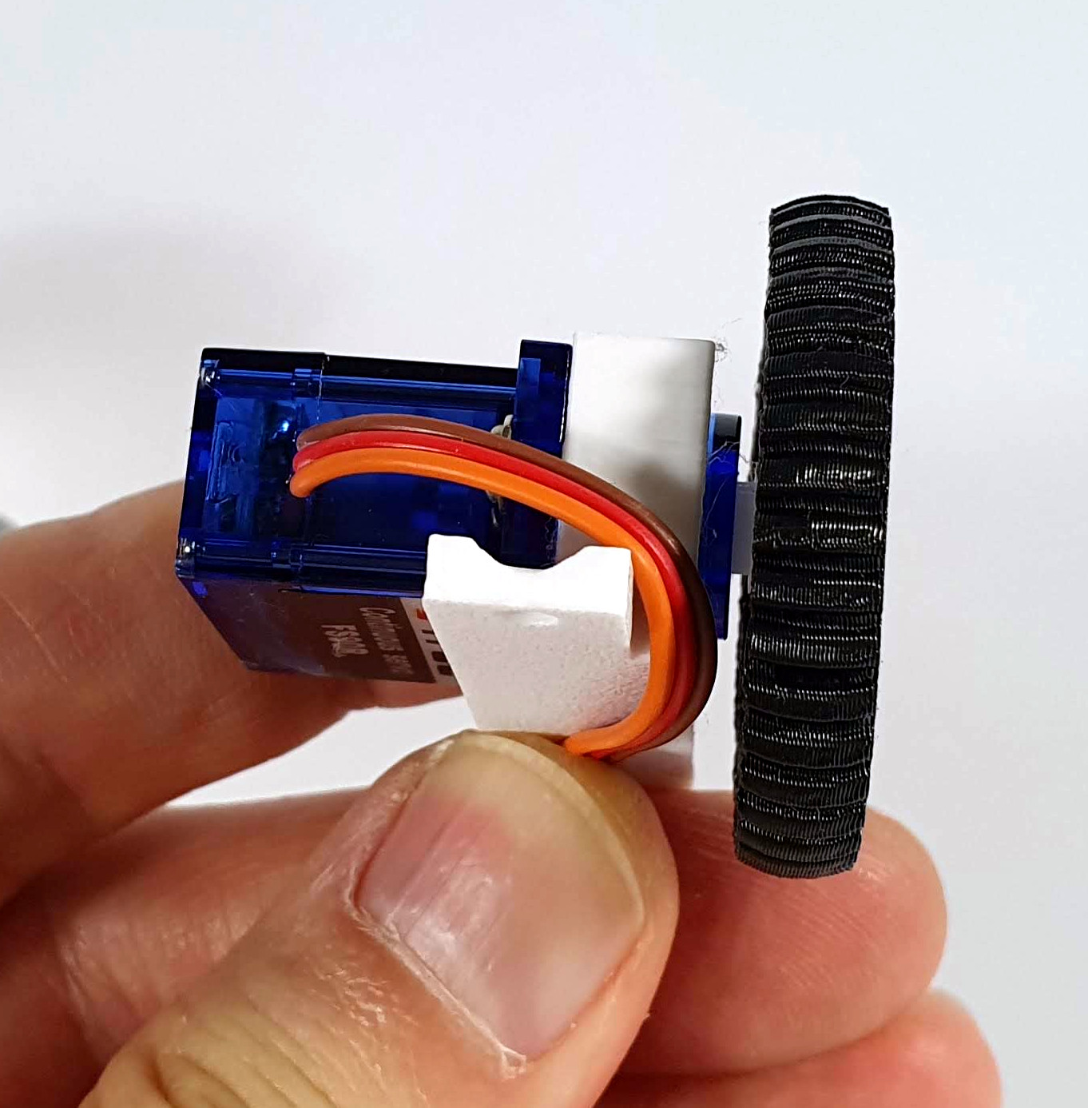
Shape the servo cable along the mounting as in the photo so that it does not catch on the wheel.

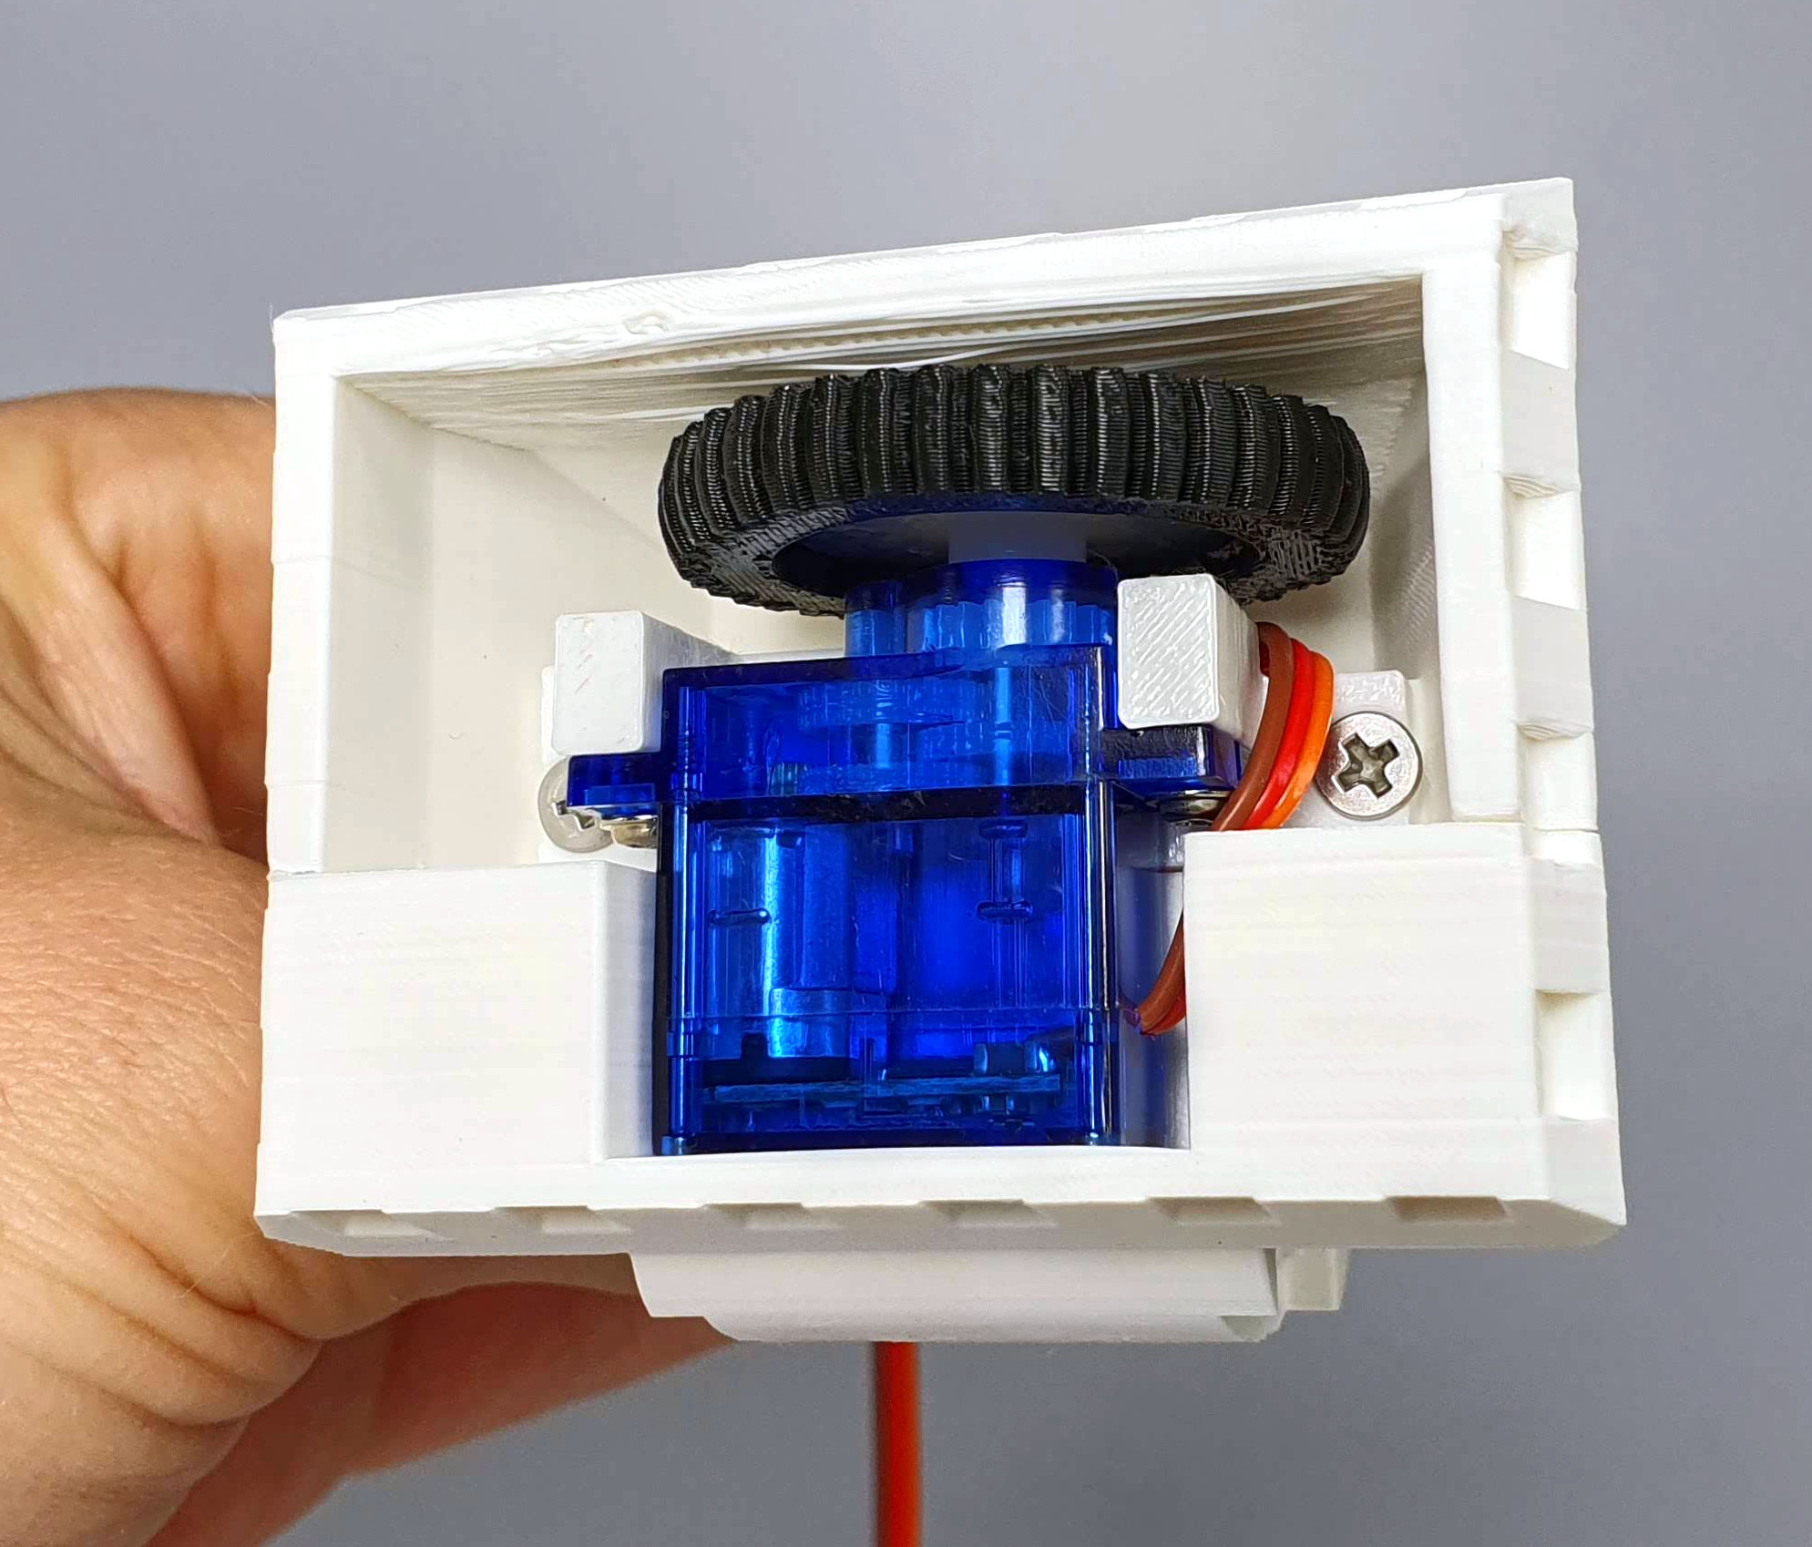

Insert the servo with the mount into the leg and screw it in with two 10mm long M3 screws.

Check whether the cable is rubbing against the wheel.

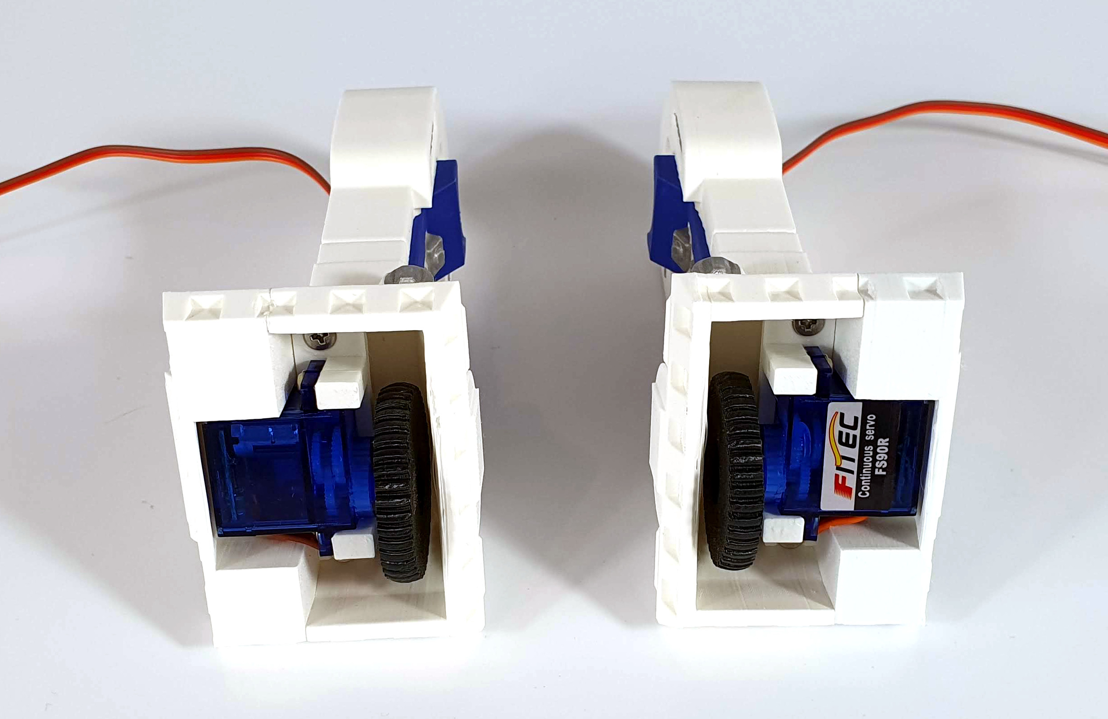
Fold your right leg in the same way, keeping in mind that it is a mirror image of the left leg.

FOLDING CENTER LEG

Put the three leg elements together and secure from the bottom with a 12mm long M3 screw.
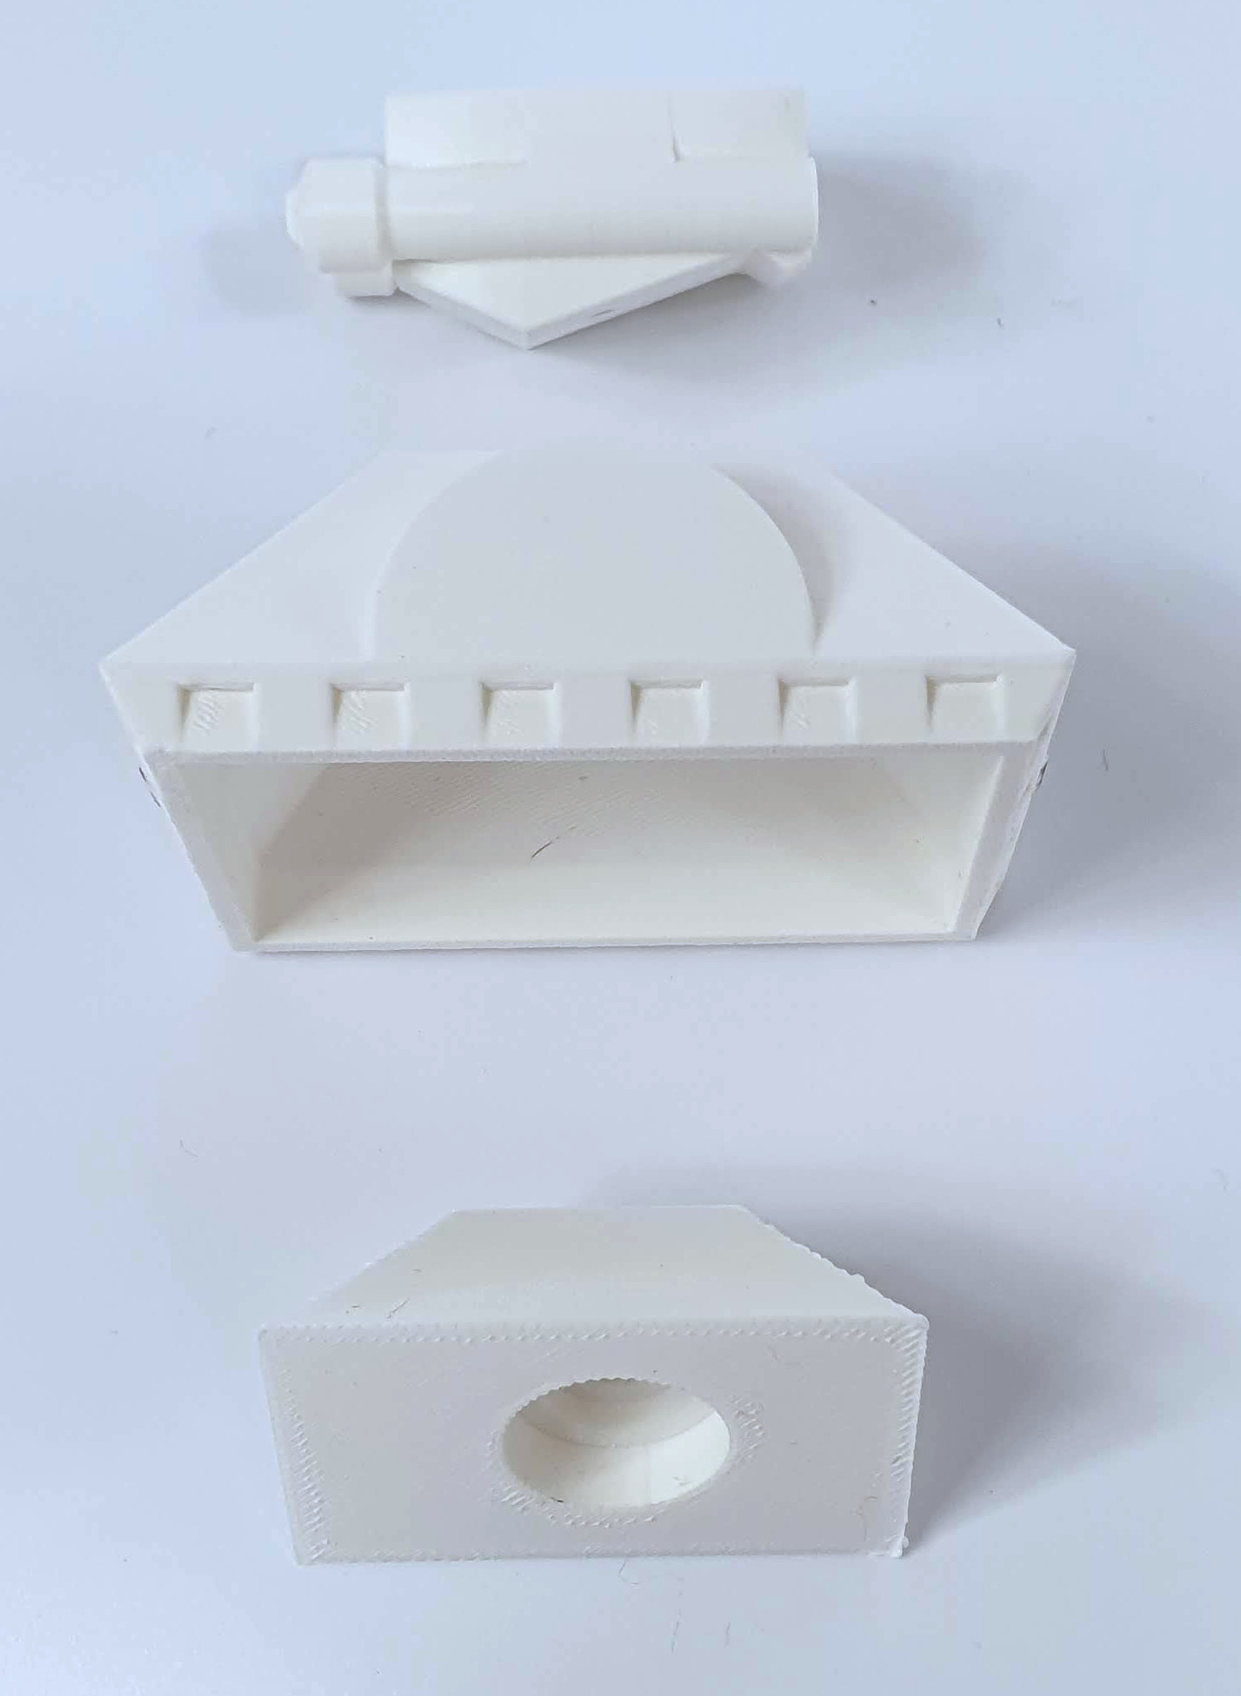
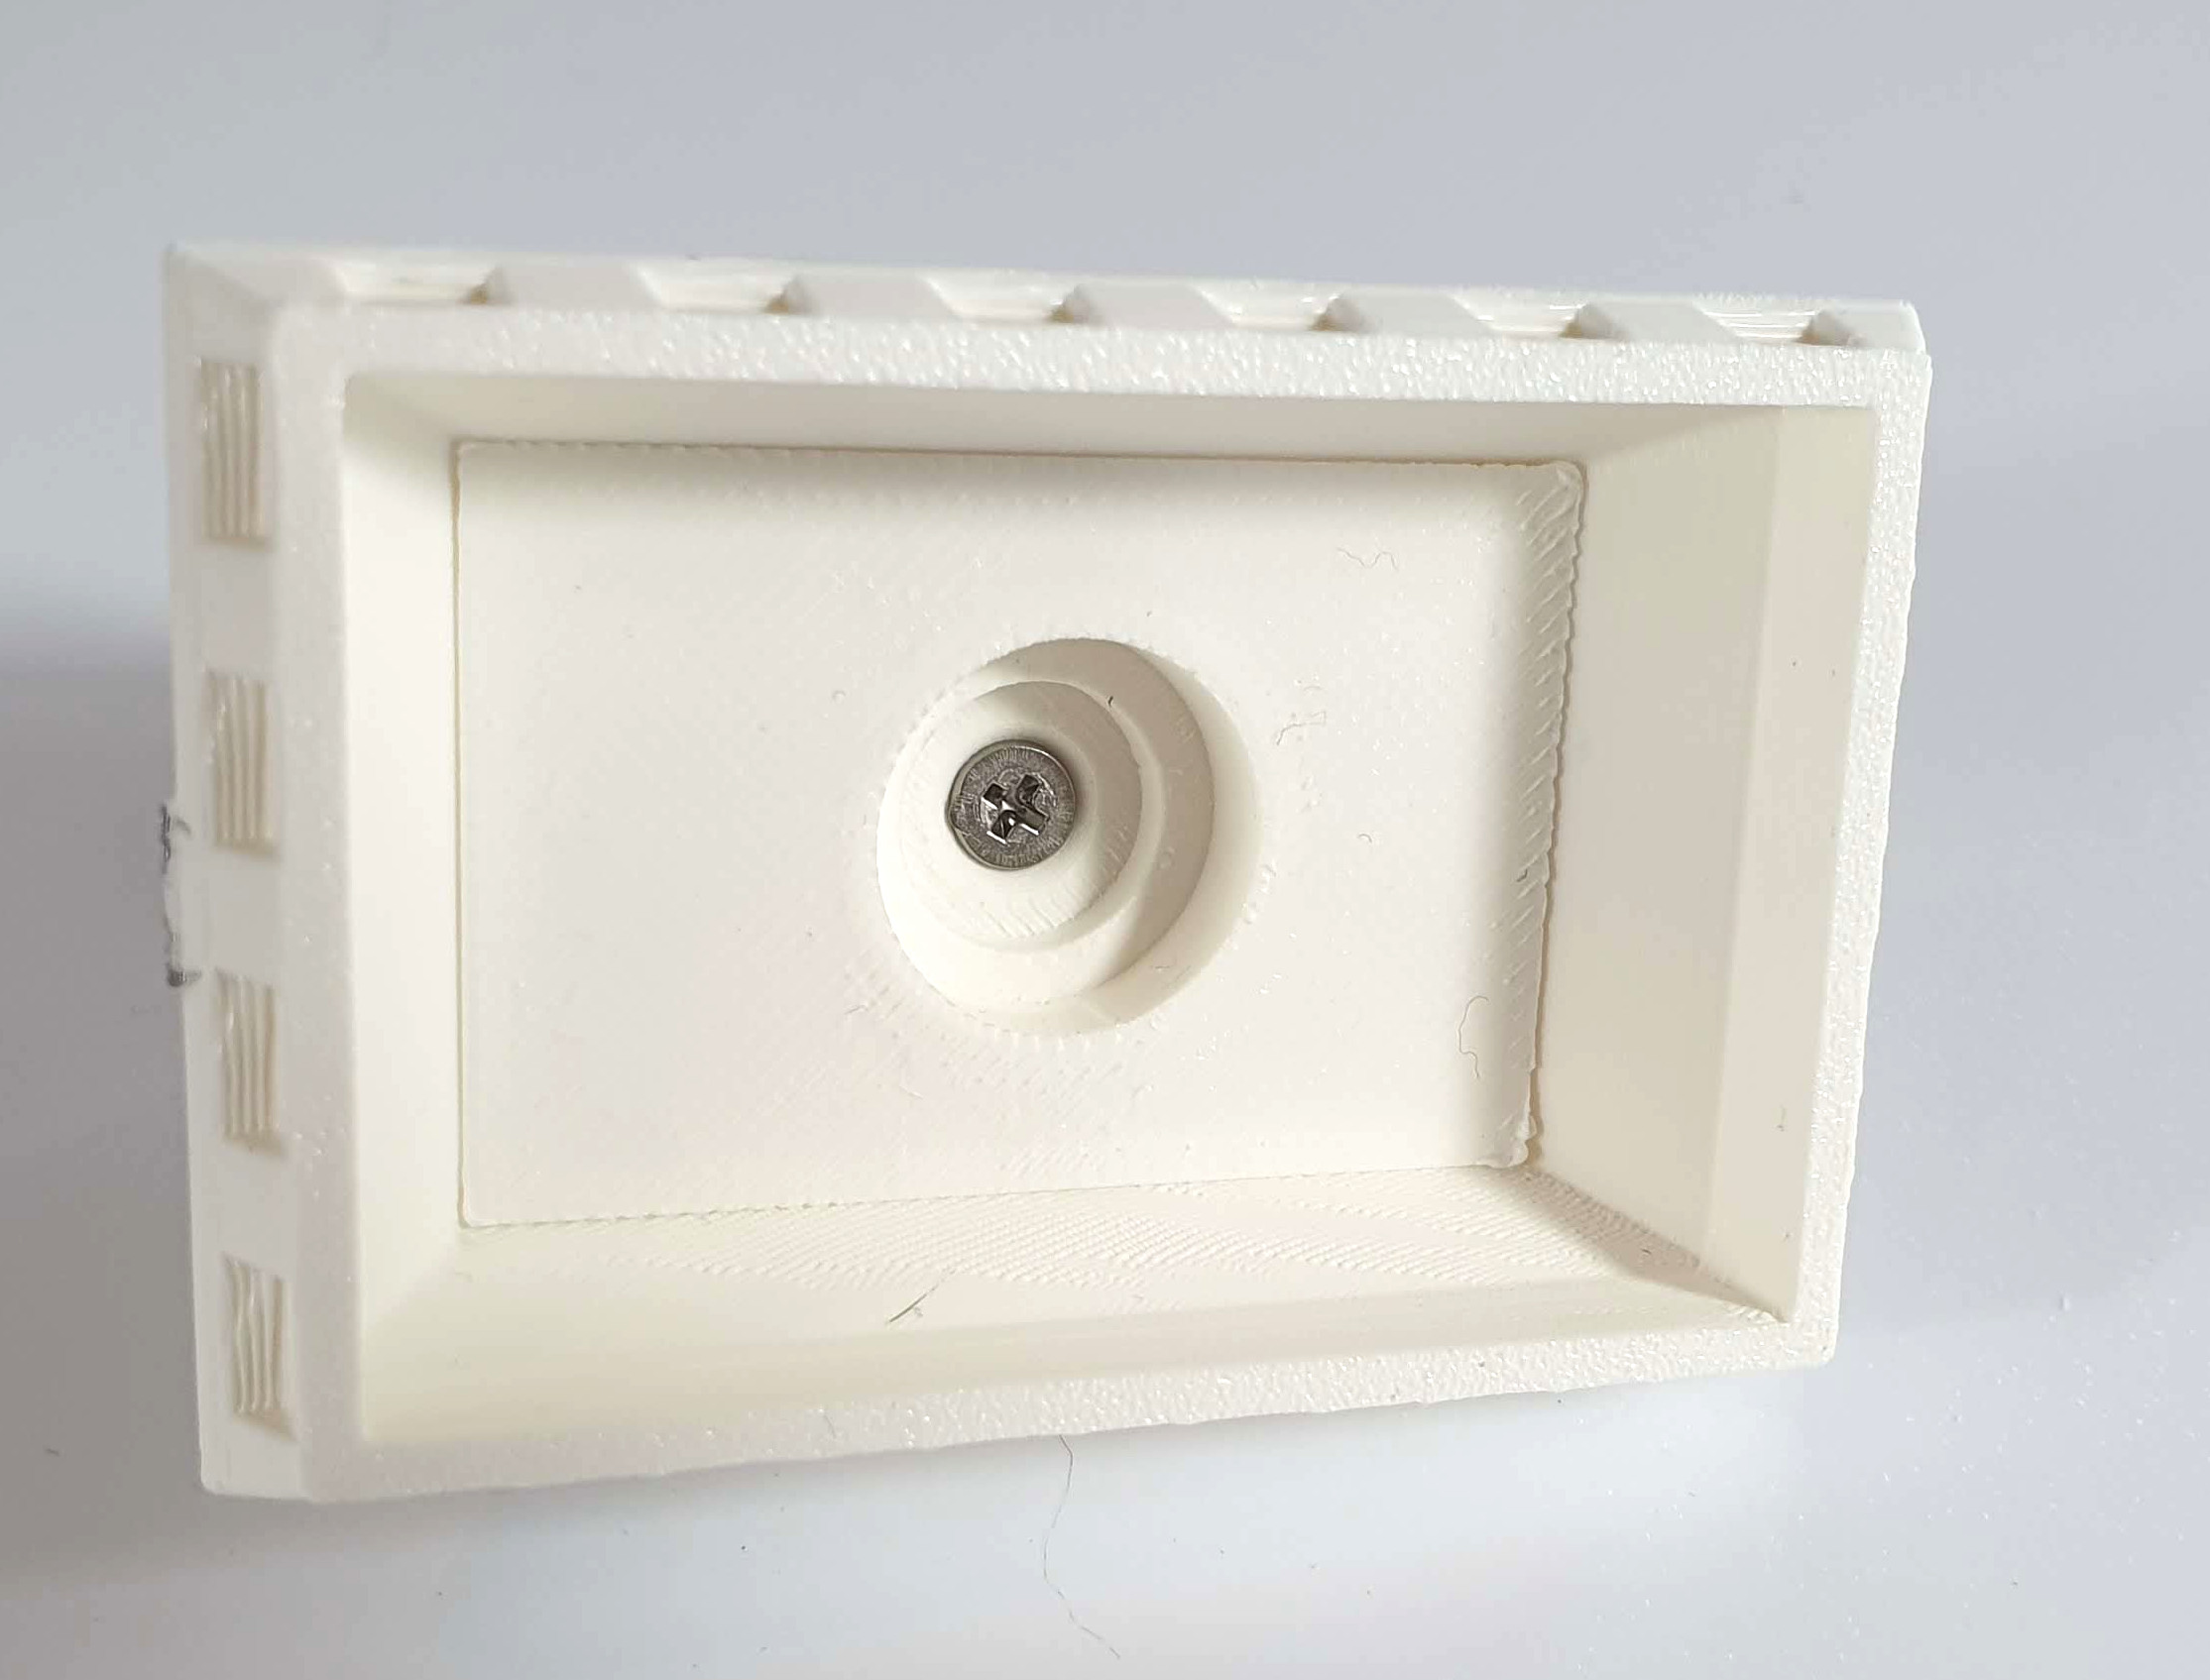
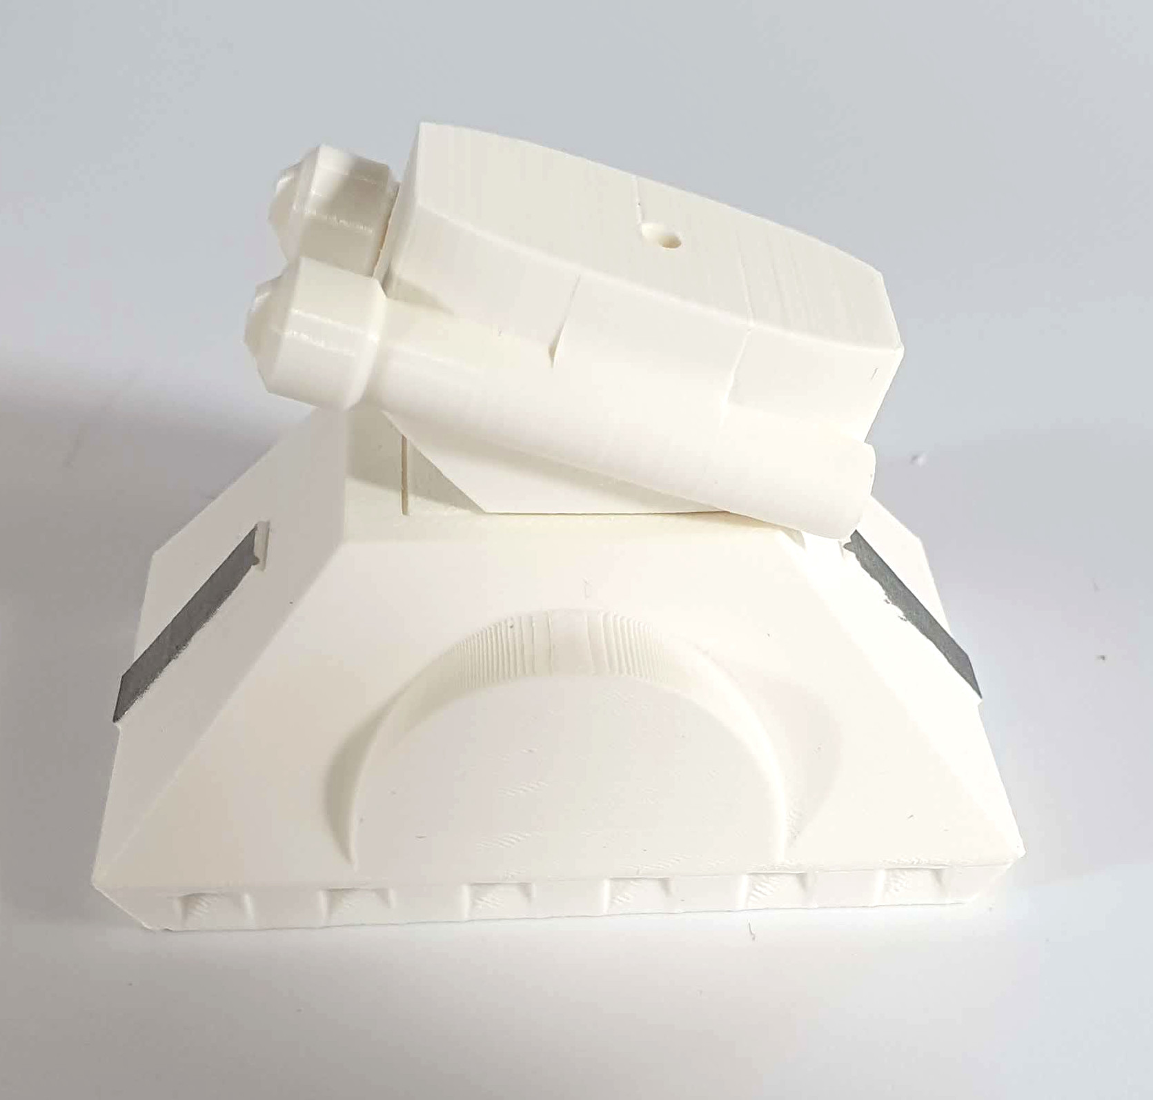
Put the pieces of the wheel together. Place the small bearing into the small rubber tire. Insert the wheel with the bearing into the caster and secure it with an M3 screw with a half-round head (the only one in the set of screws) 10 mm long.
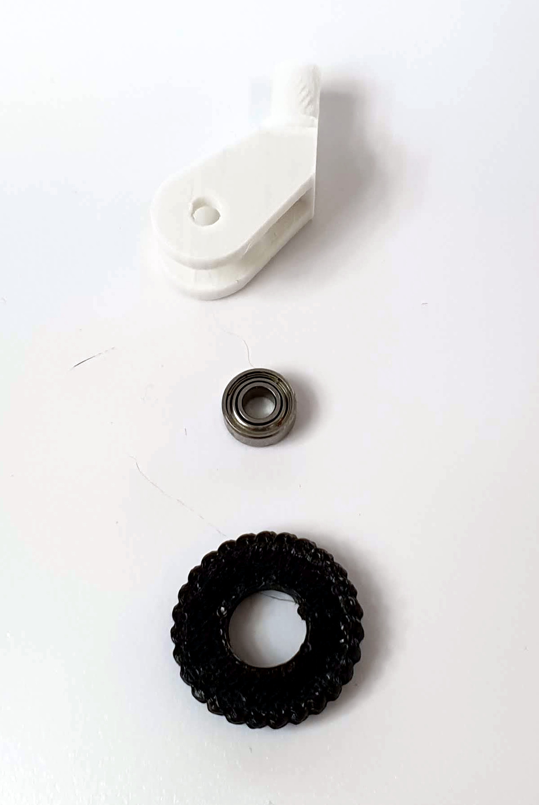
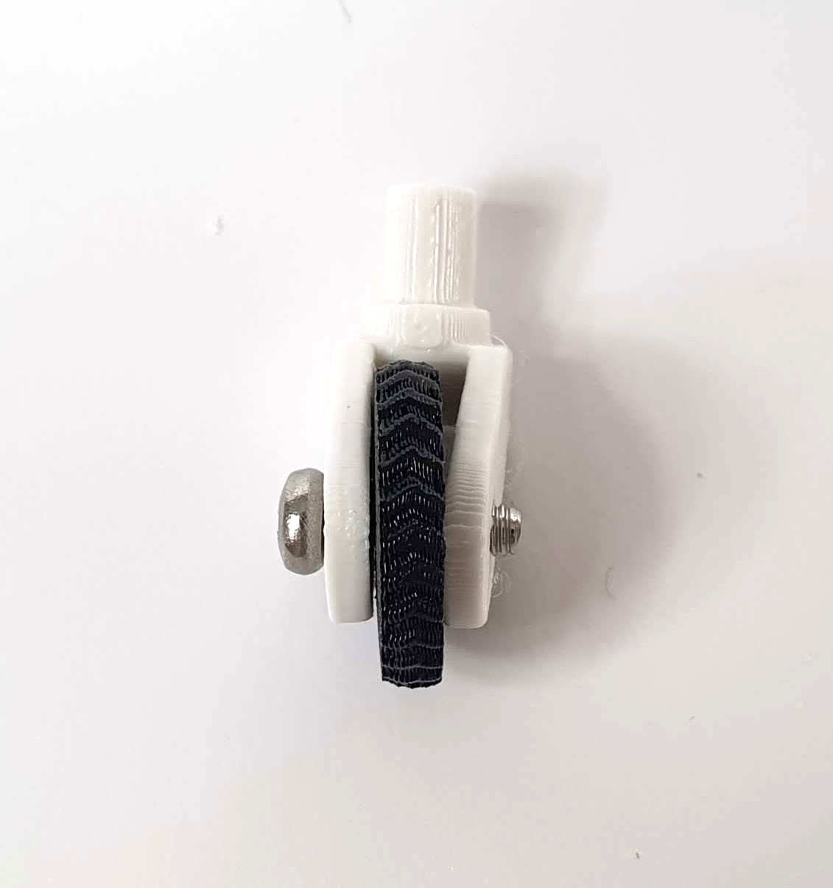
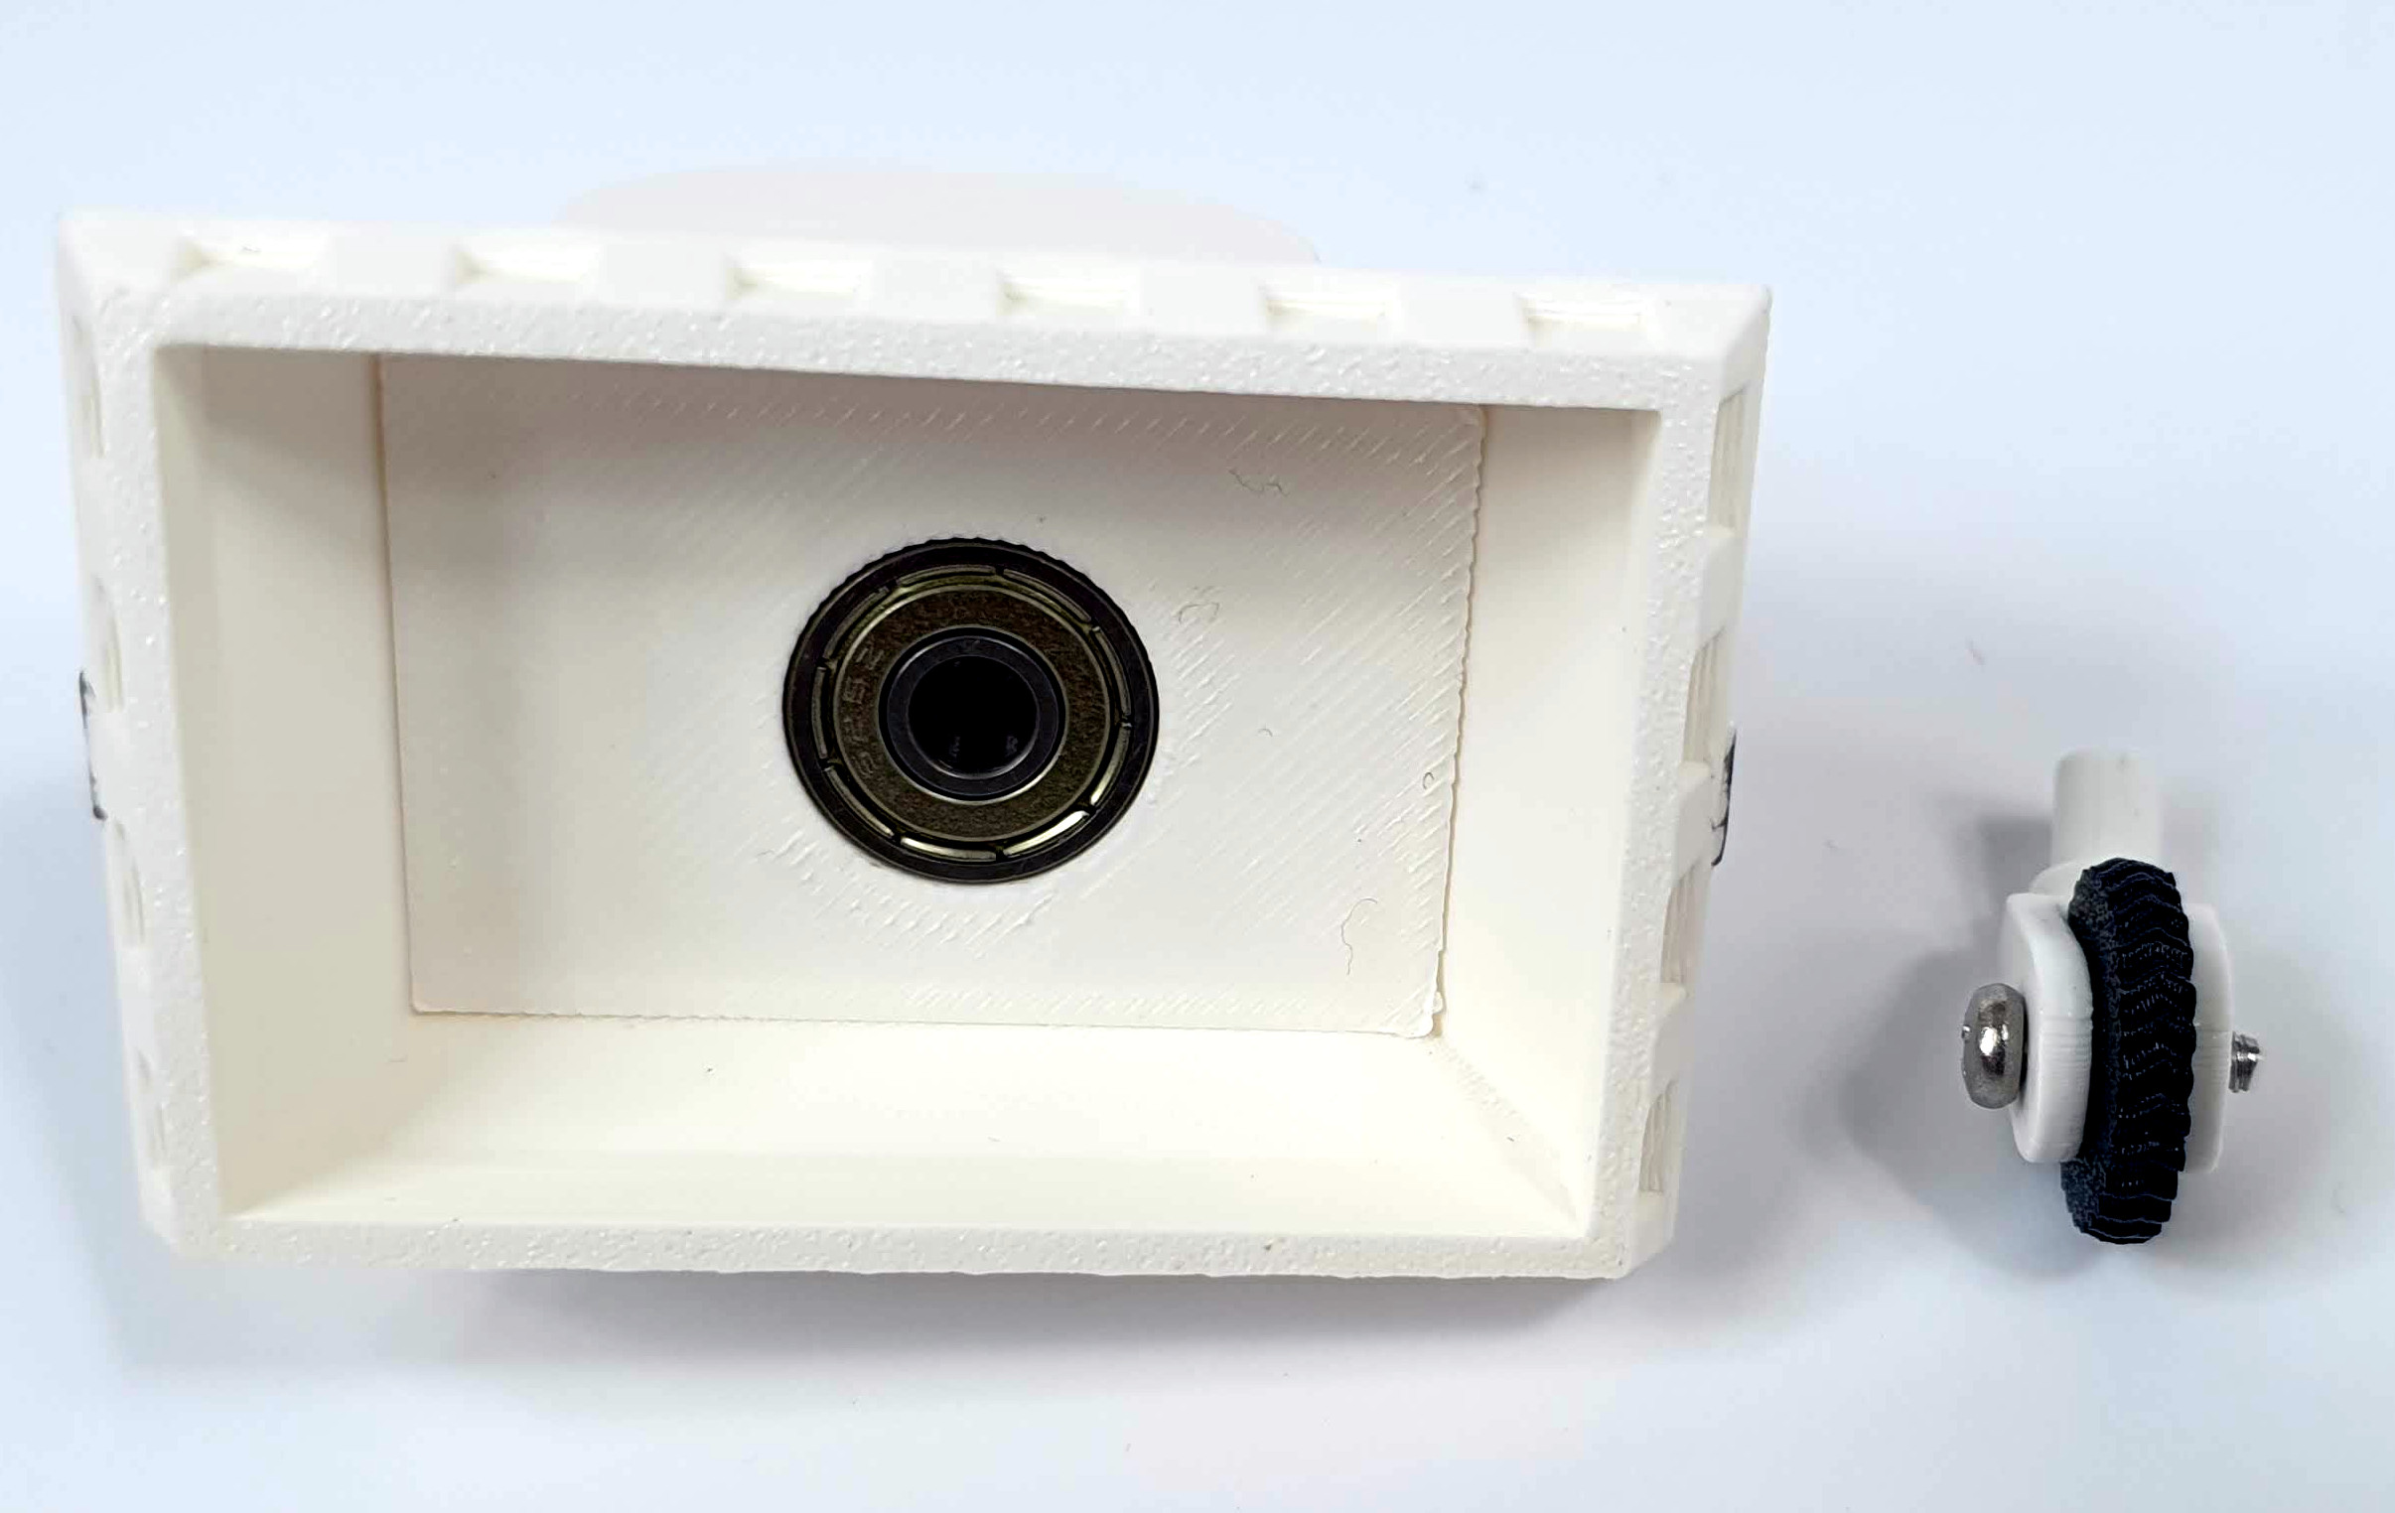
Insert the large bearing from the bottom of the leg and insert the folded wheel into it. The wheel should rotate freely around the bearing axis.

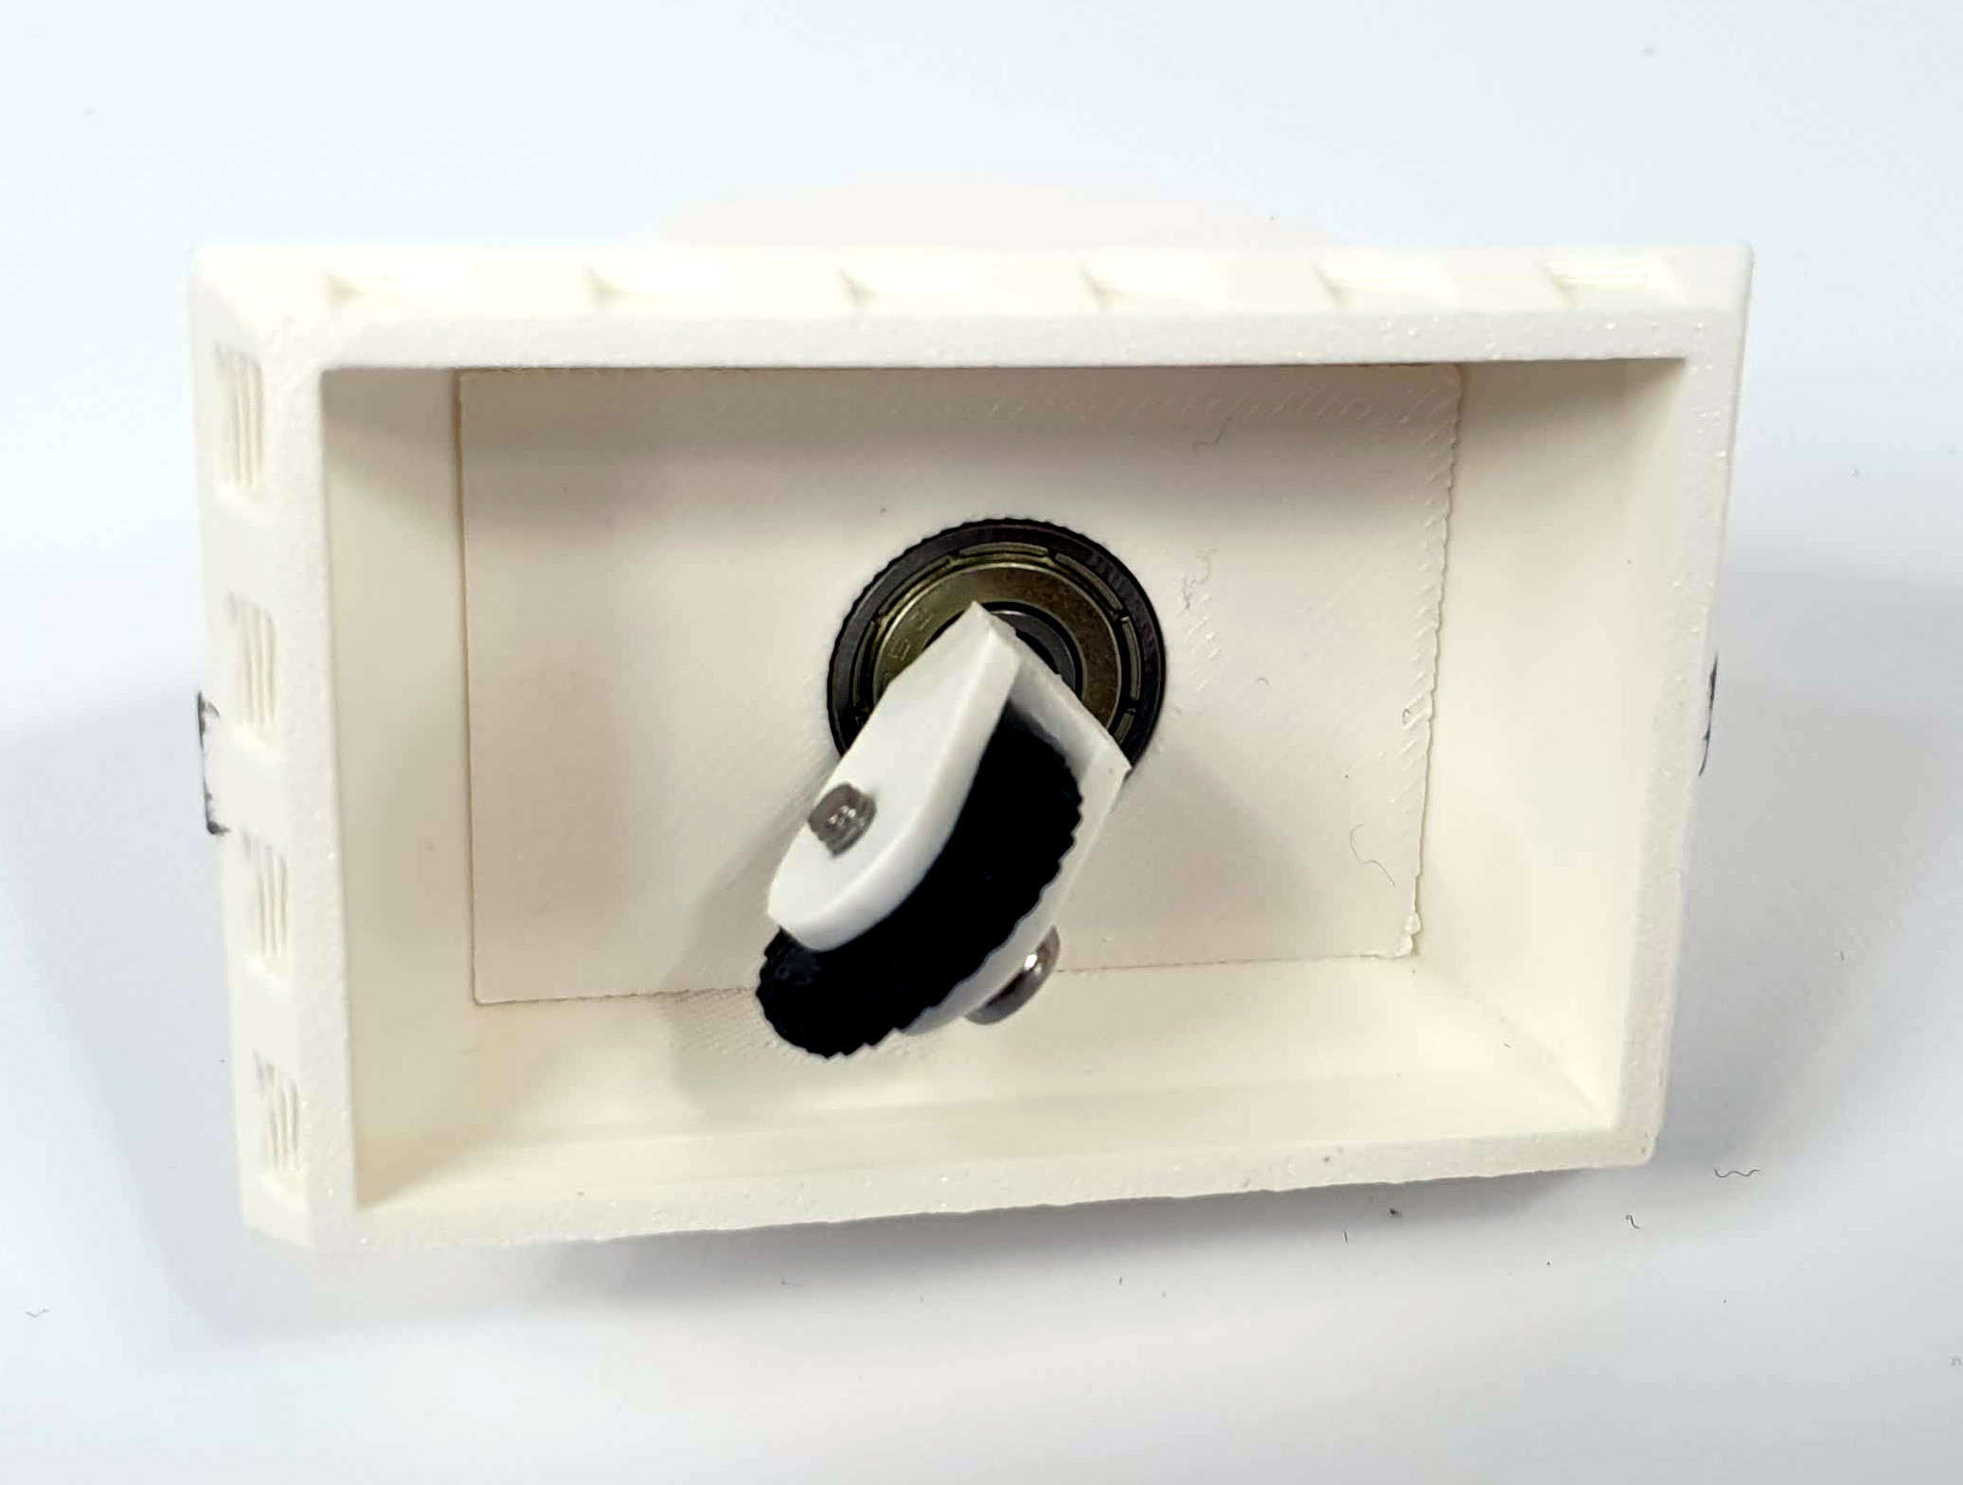
FOLDING HEAD ROTATION MECHANISM

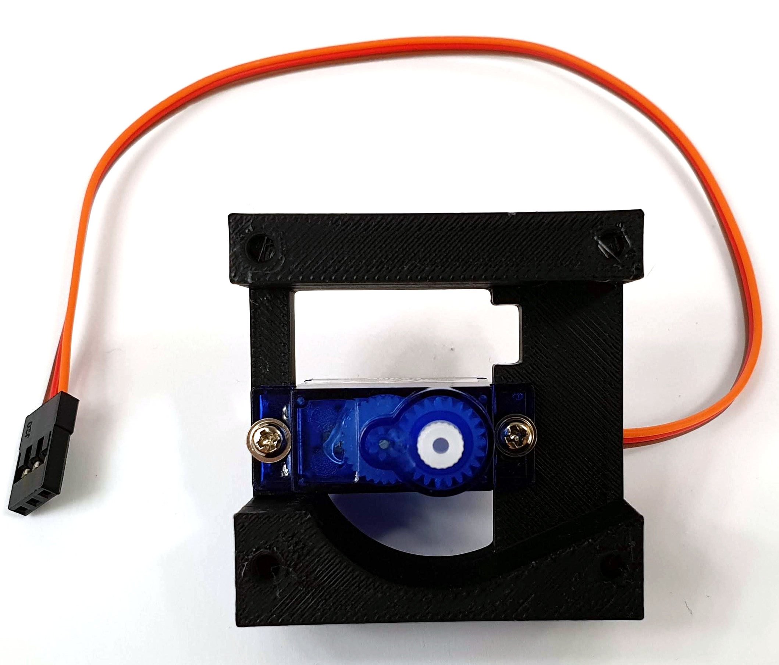
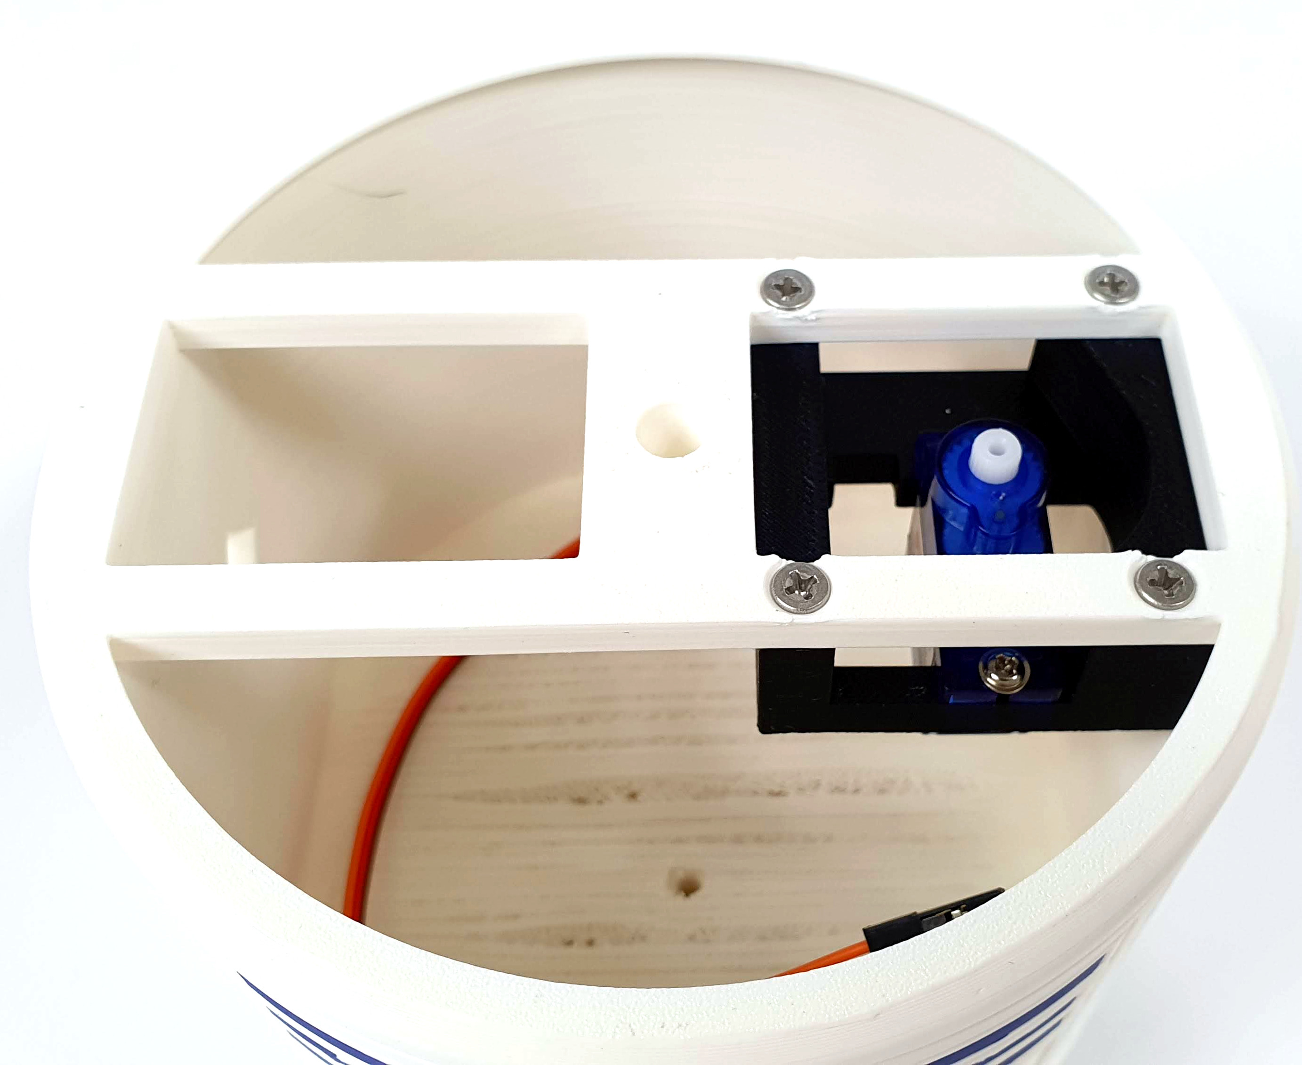
Screw the head rotation servo to the mount using screws A. Place the assembled mount together with the servo inside the body and secure the whole thing with 4 M3 screws, 10 mm long.
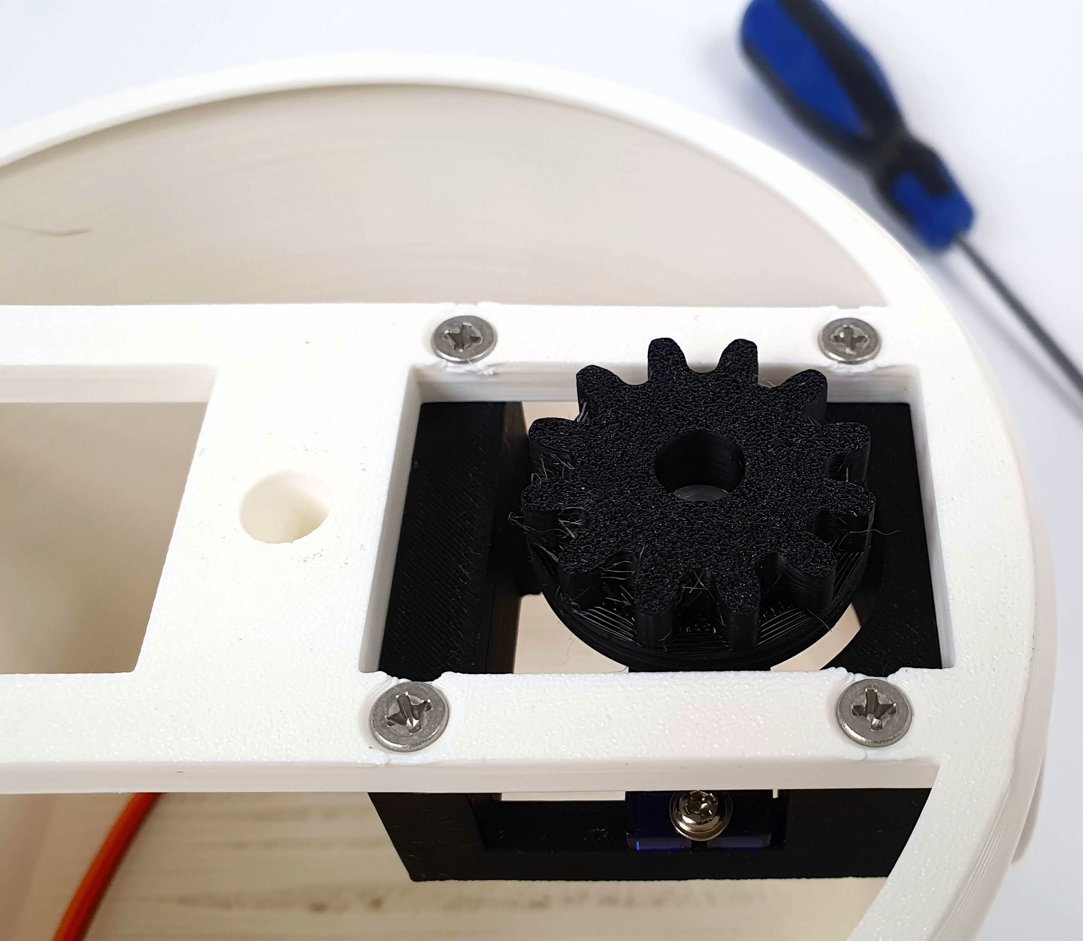
Attach the head drive sprocket to the servo with screw B.

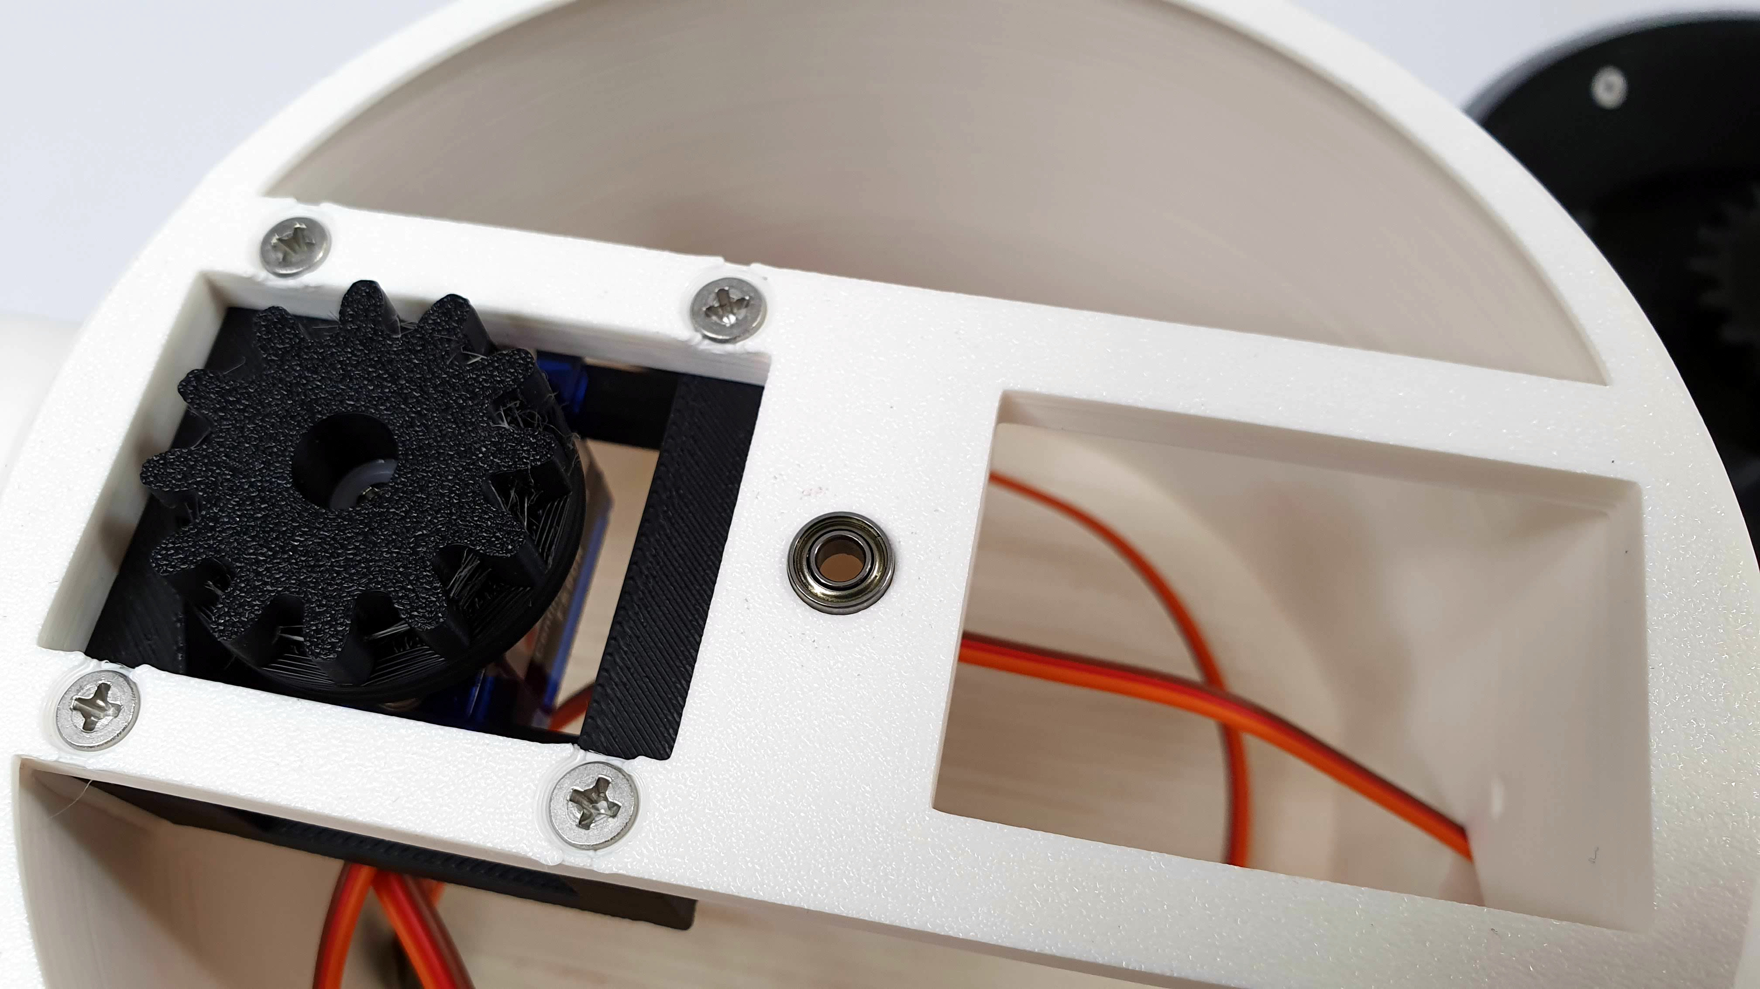

Insert 3 pcs. small bearings into the central hole.
They will serve as the rotation axis of the droid's head.

ATTACHING THE LEGS TO THE BODY

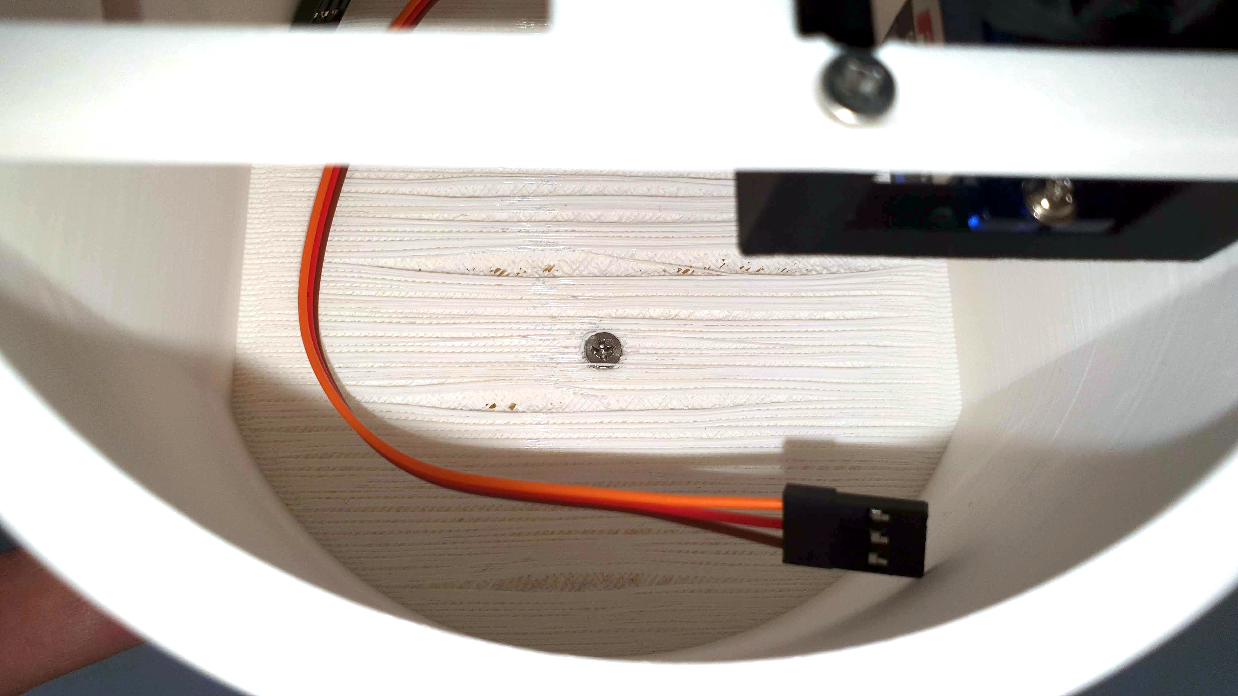
Secure the leg with the middle M3 screw, 20mm long, inserting it from the inside of the body.

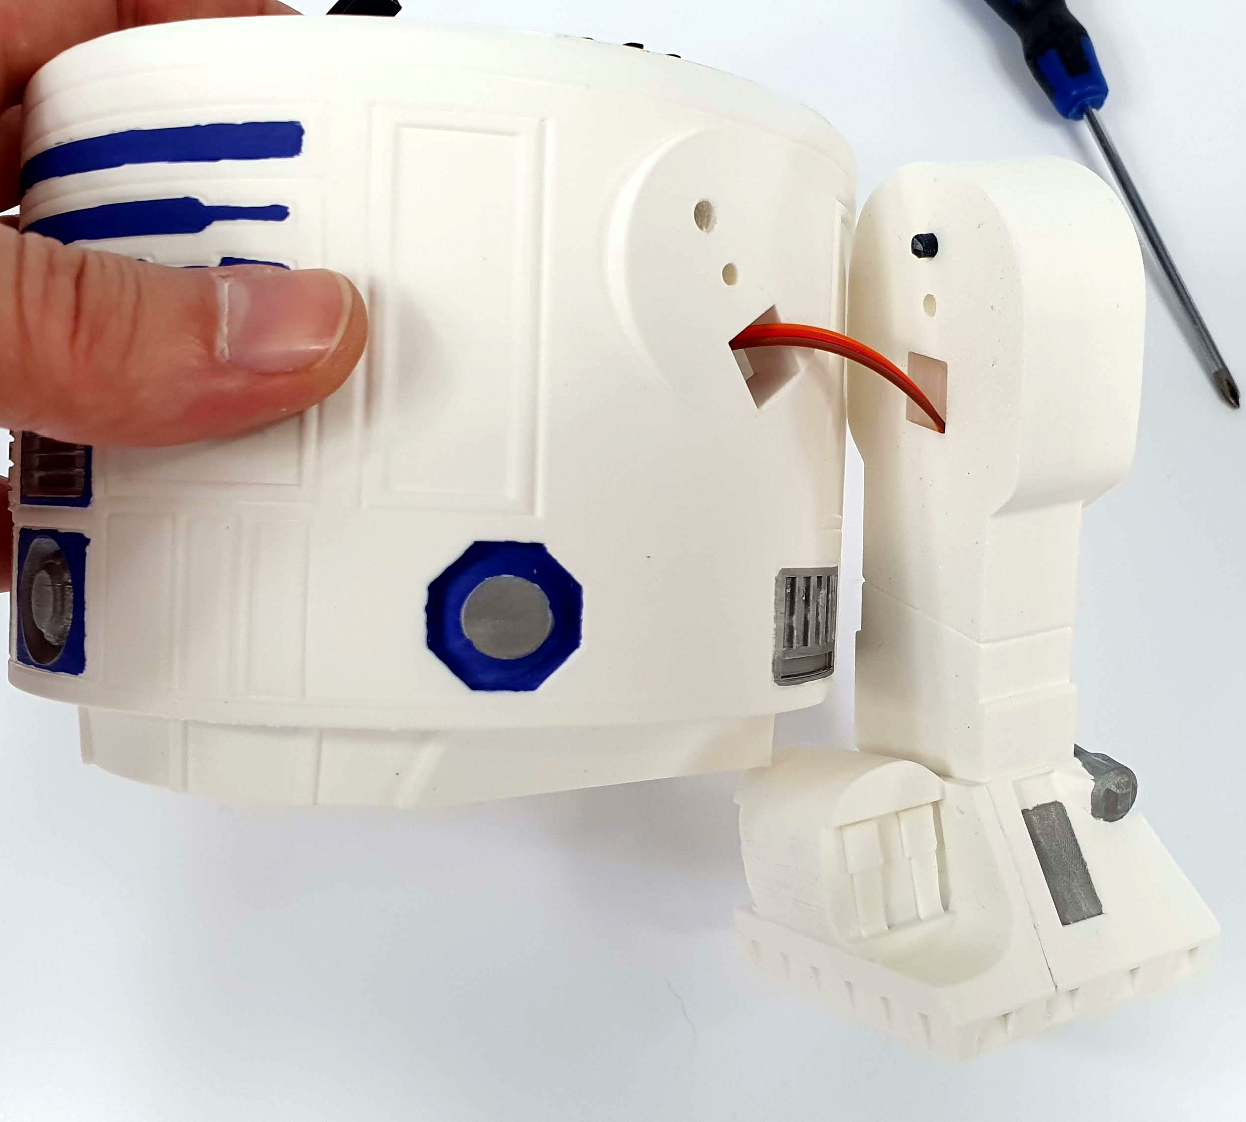

Insert the servo cable through the hole in the body.

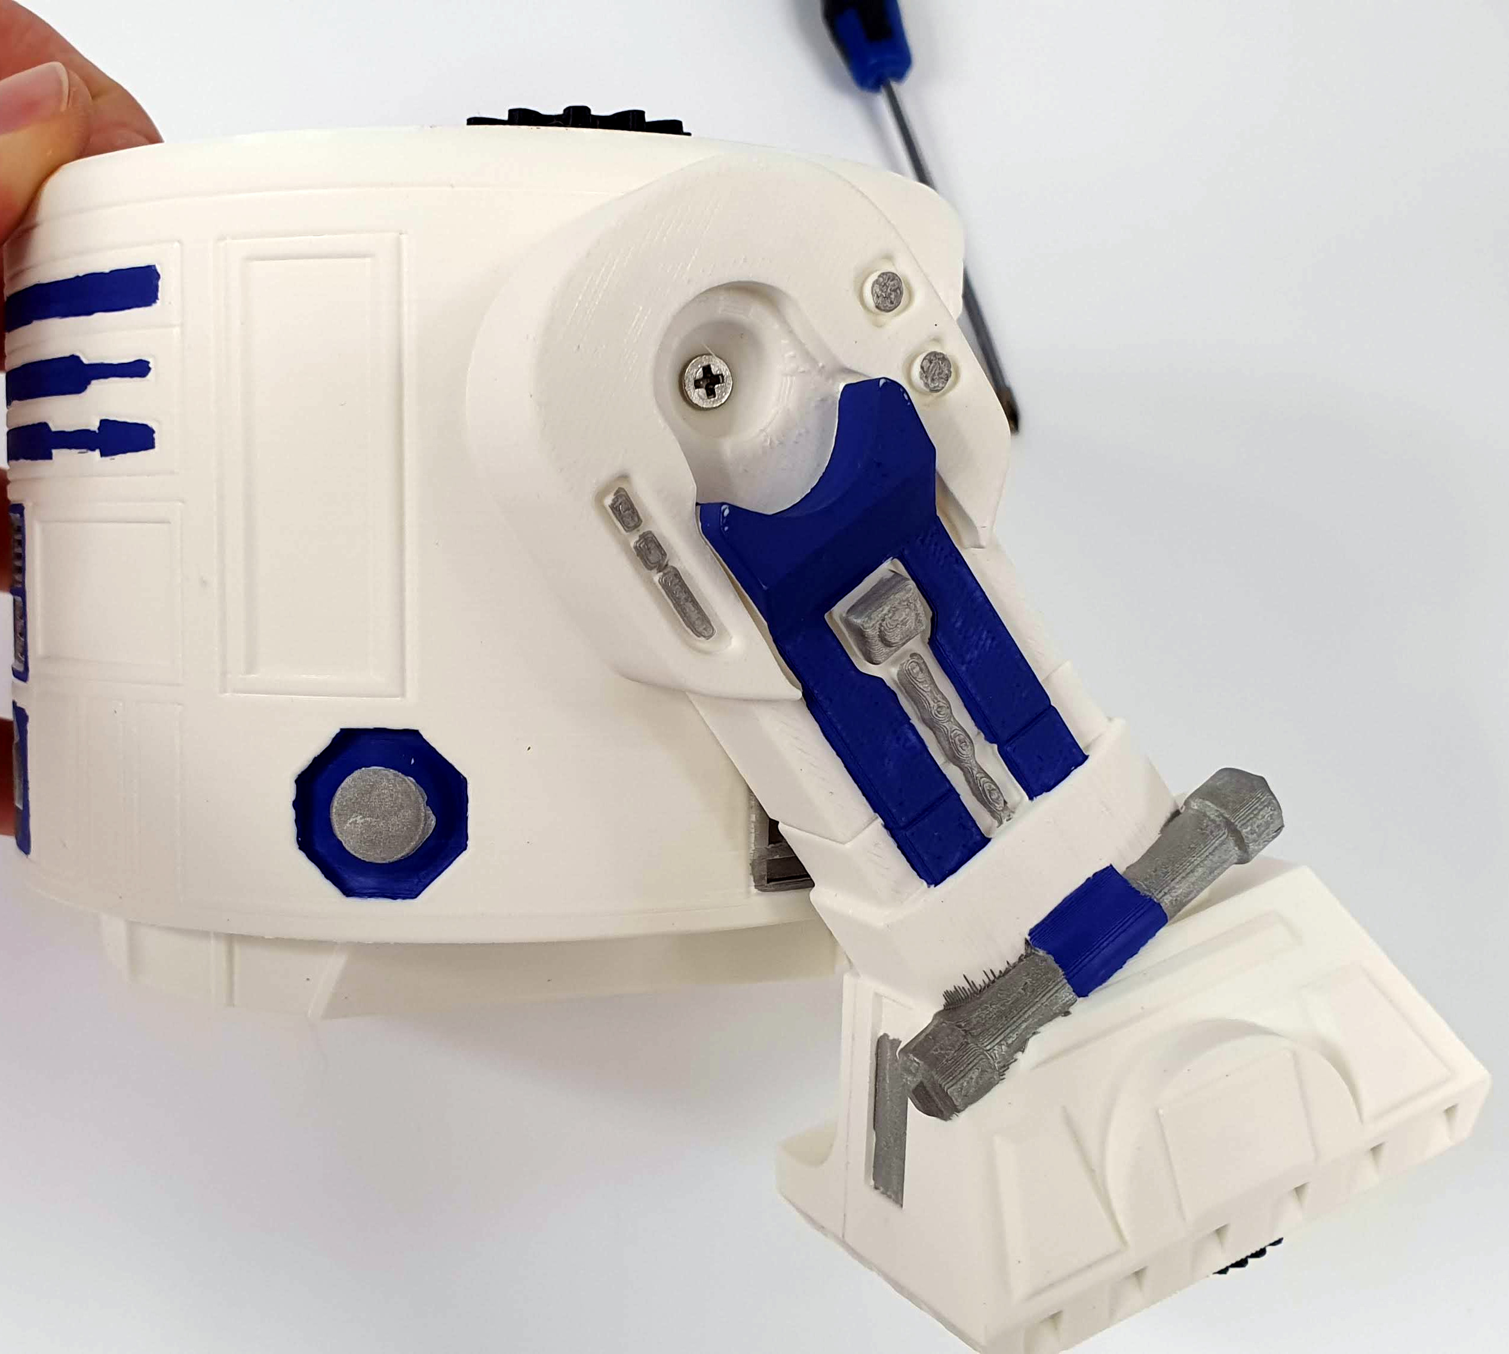
Screw the leg to the body using a 20mm long M3 screw.
Repeat the same with the other leg.

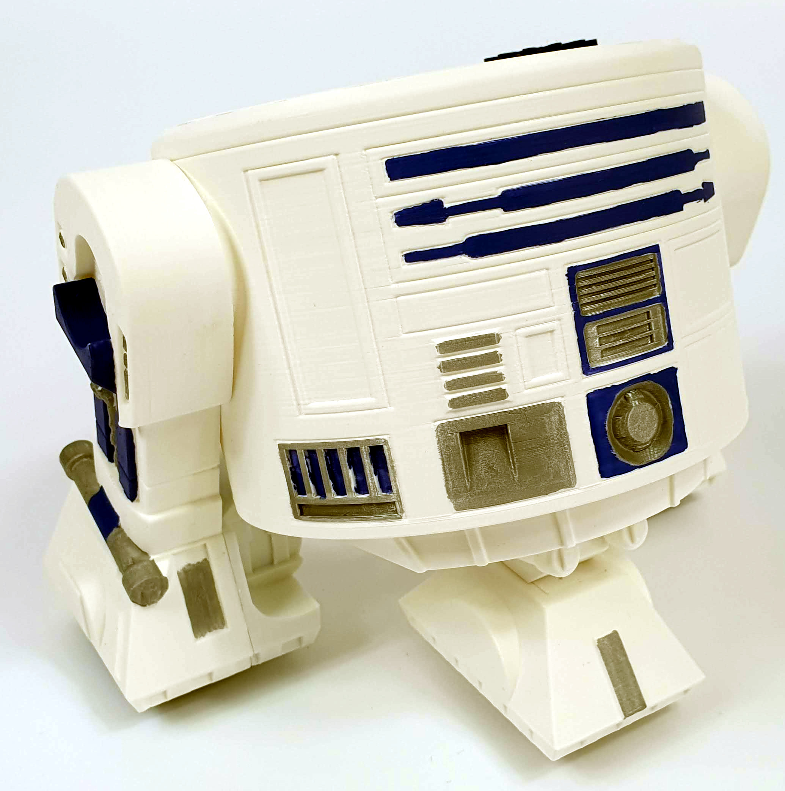

HEAD ASSEMBLY (applies only to R2, R4, R9 versions)

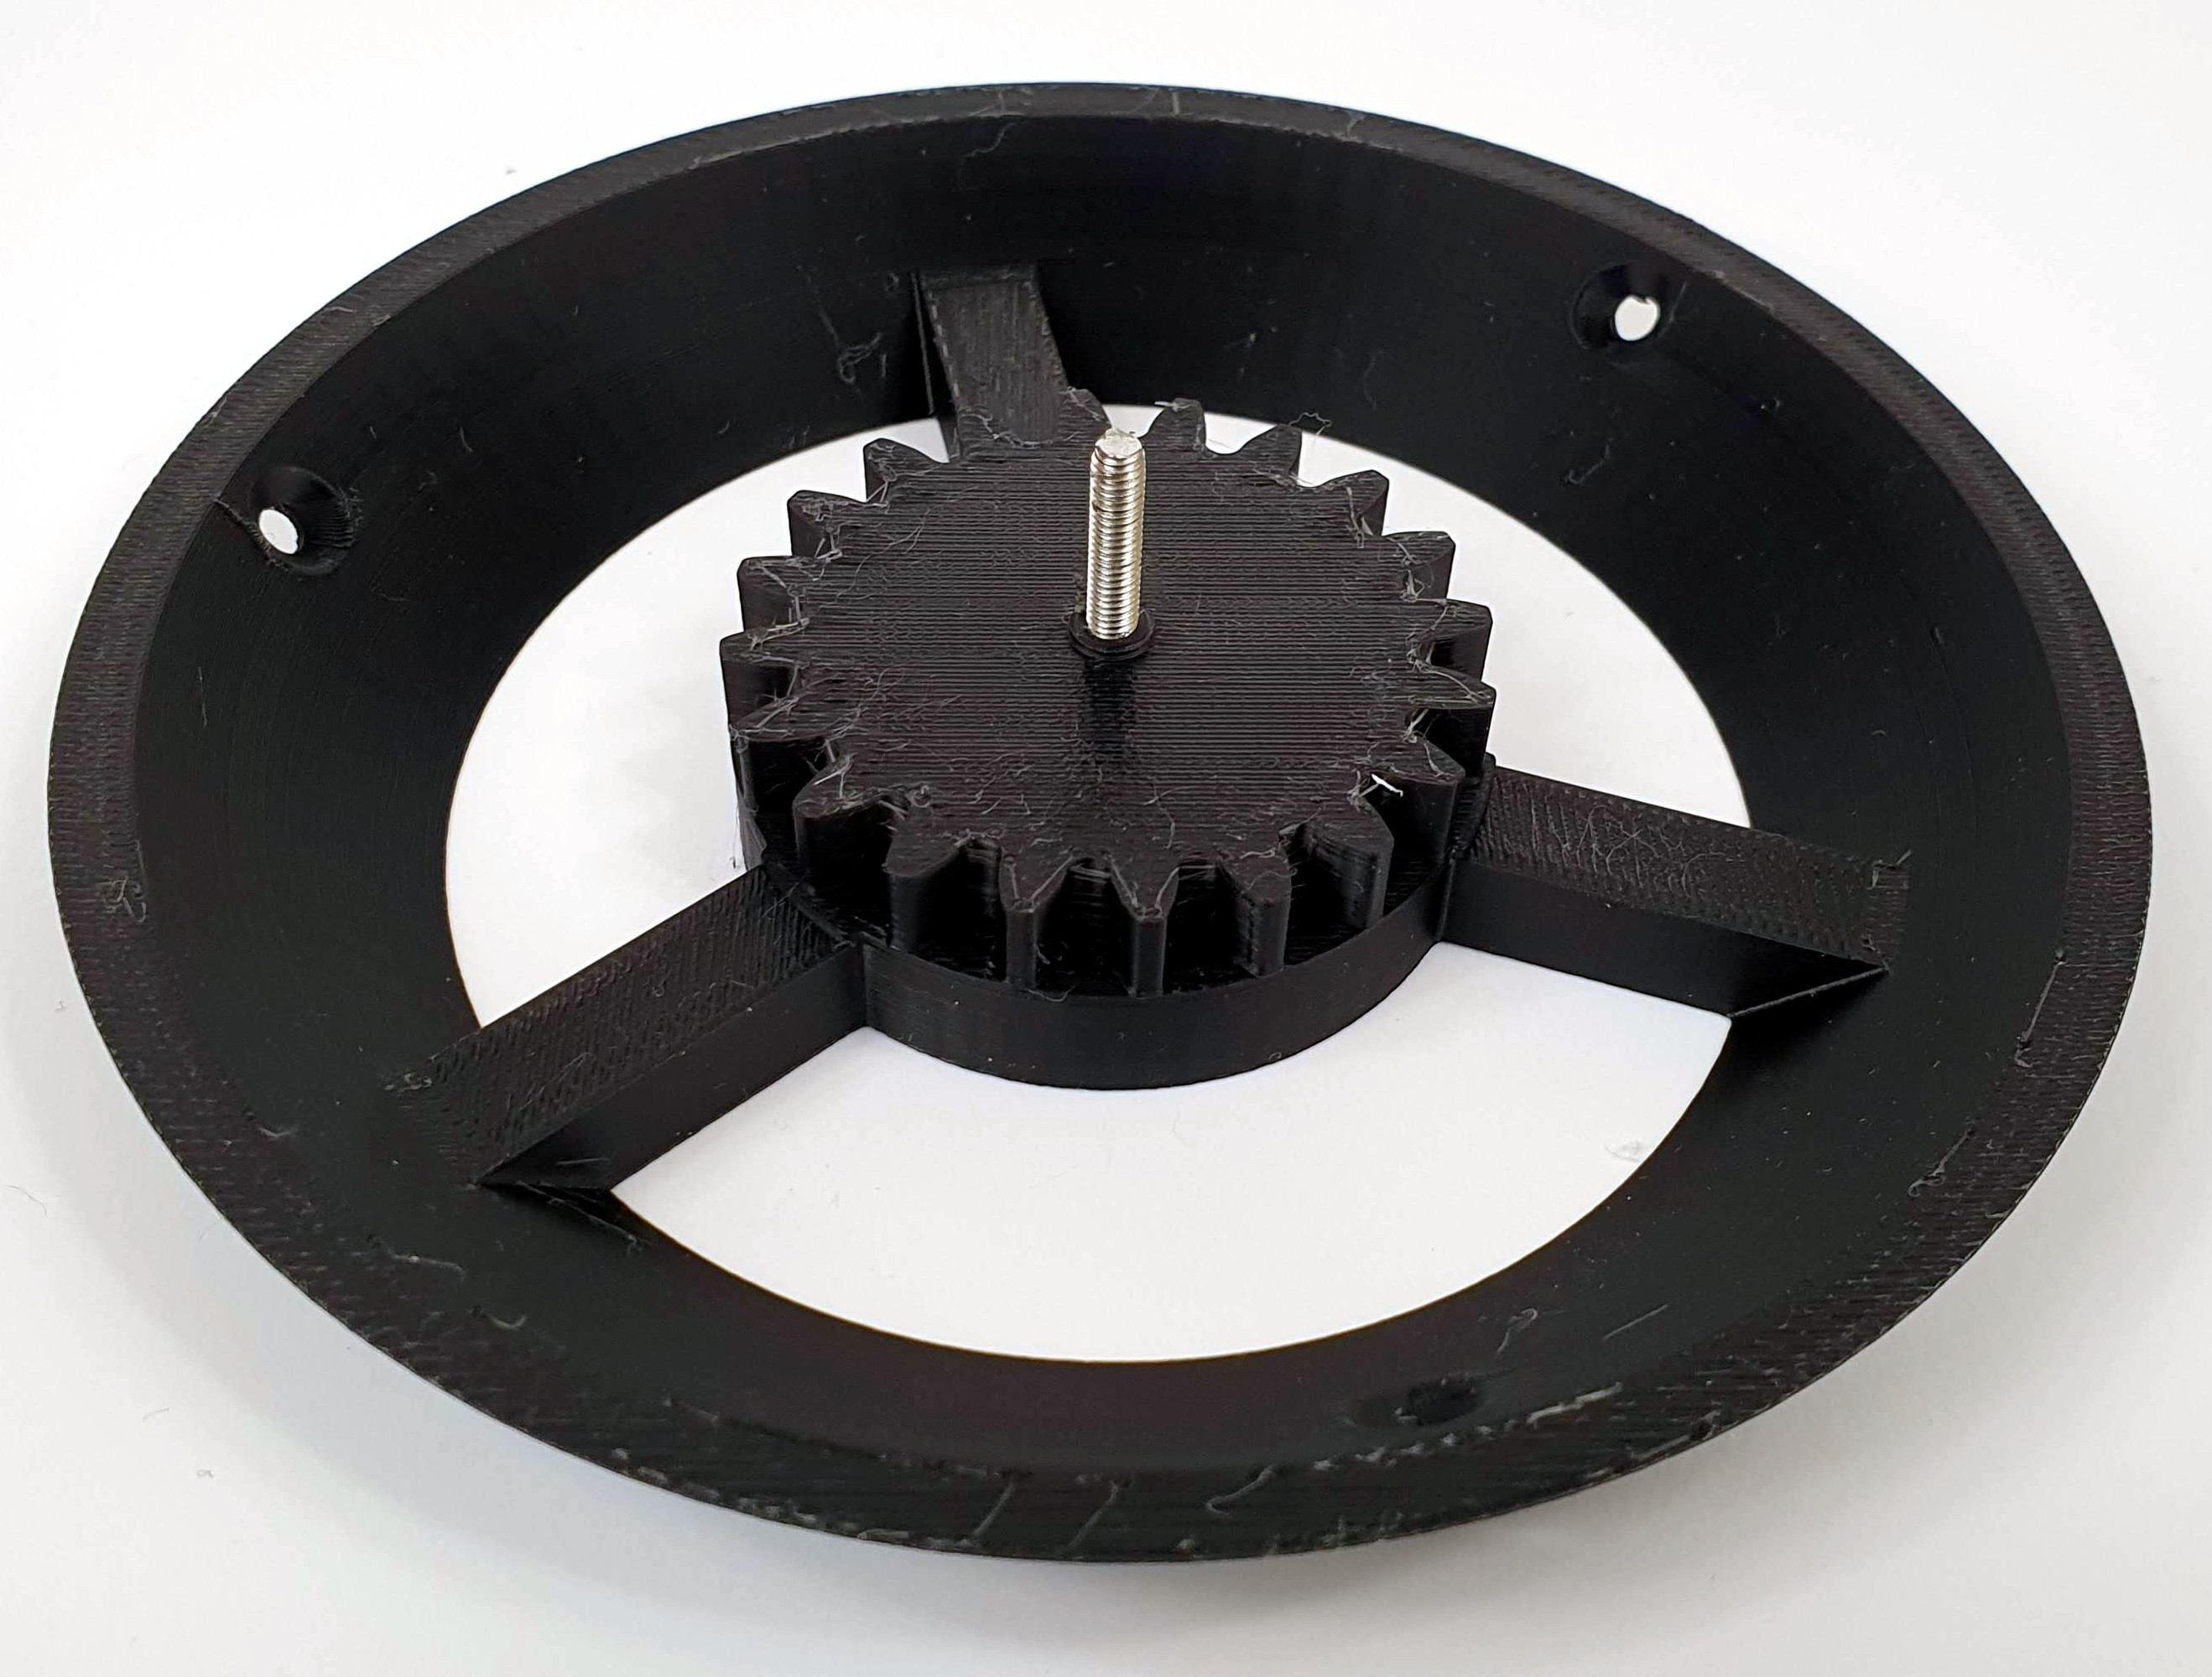
Screw a 20mm long M3 screw into the head mounting hole as in the photo.

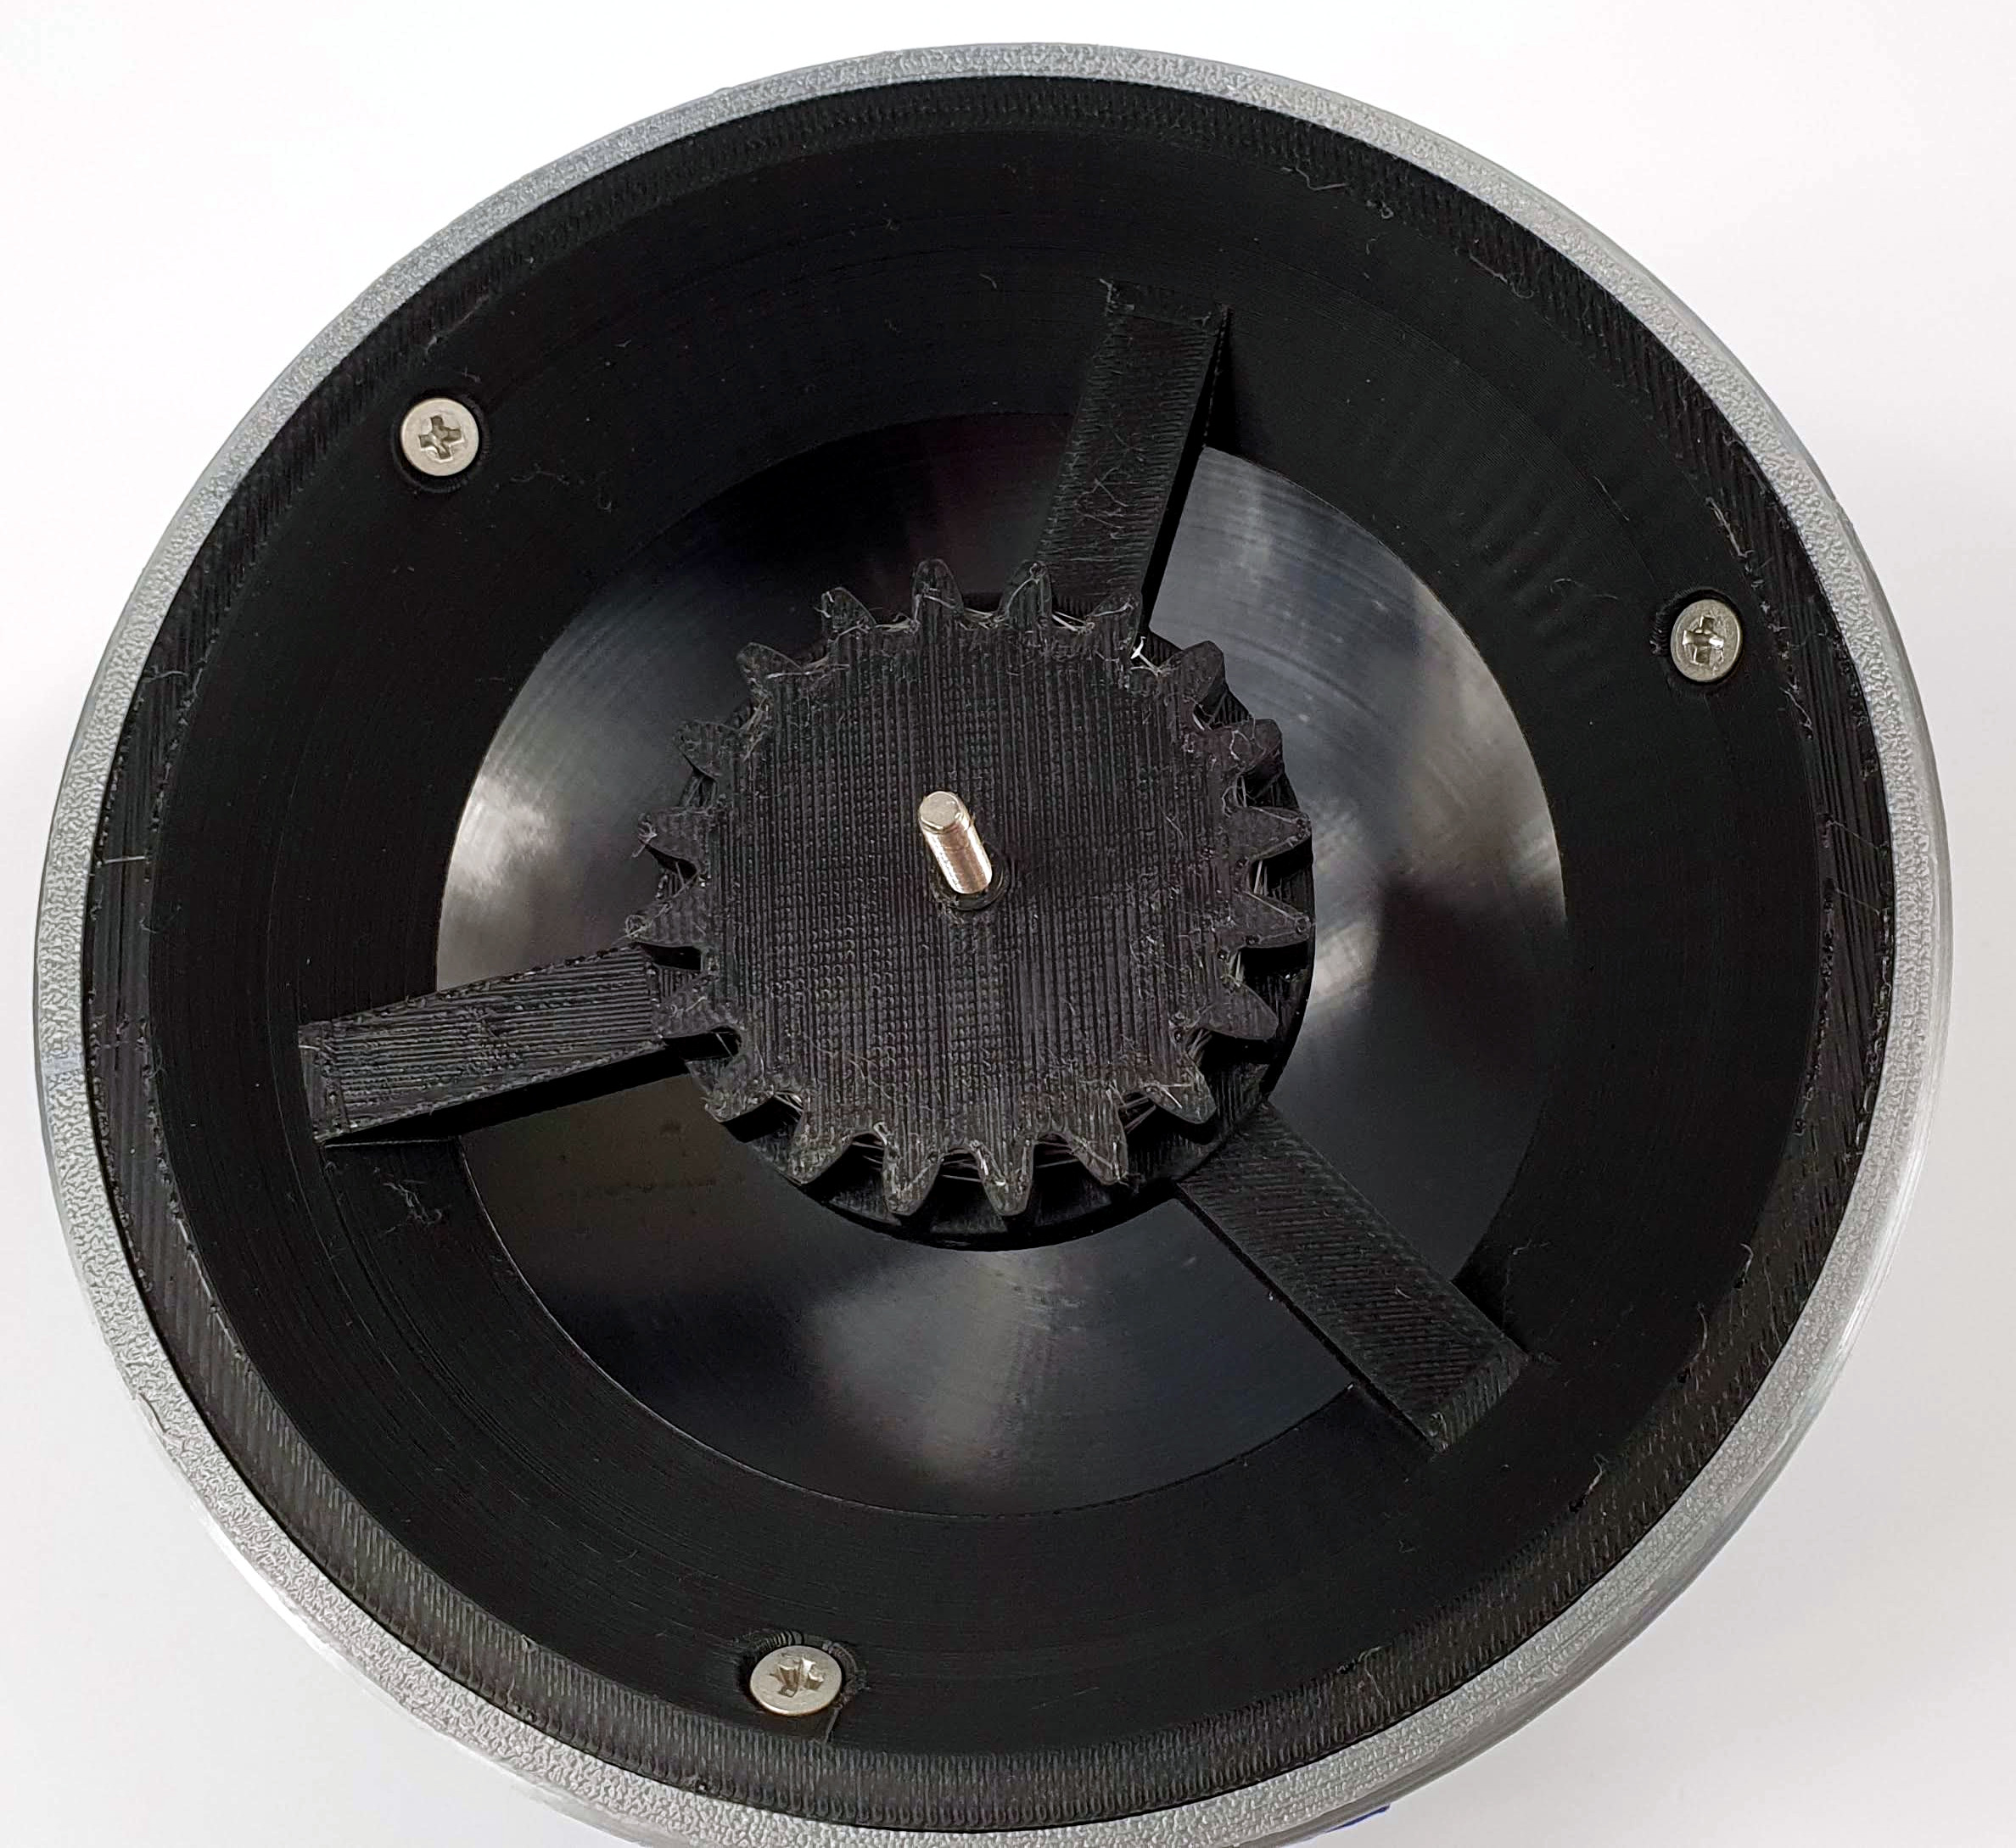

Screw the head to the mount with 3pcs. M3 screws, 8mm long.

ELECTRONIC INSTALLATION

Install the processor and sound module boards to the main board. Insert the Micro SD card into the sound module. Only fits with the subtitles facing up. Don't force it!
Connect the speaker to the socket.
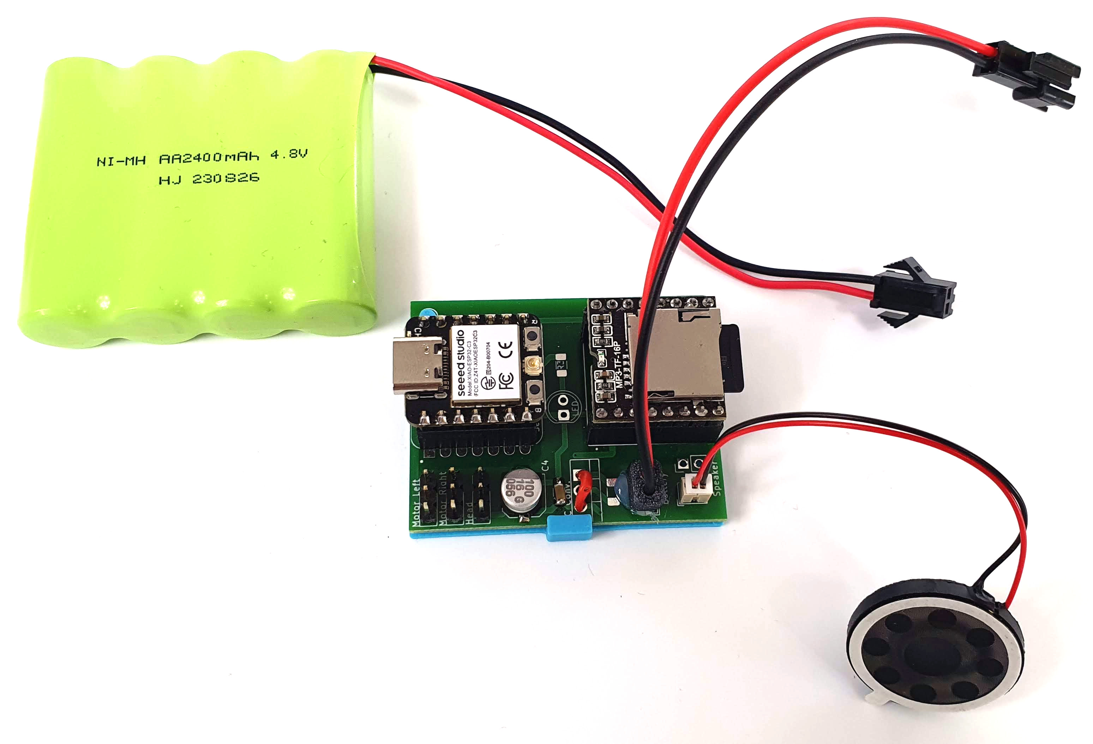
Connect the servo cables to the board according to their markings:
Left leg – Motor Left (looking from the back of the droid)
Right foot – Motor Right
Head rotation - Head
Pay attention to the colors of the wires in the photo! Brown color of wires OUTSIDE!
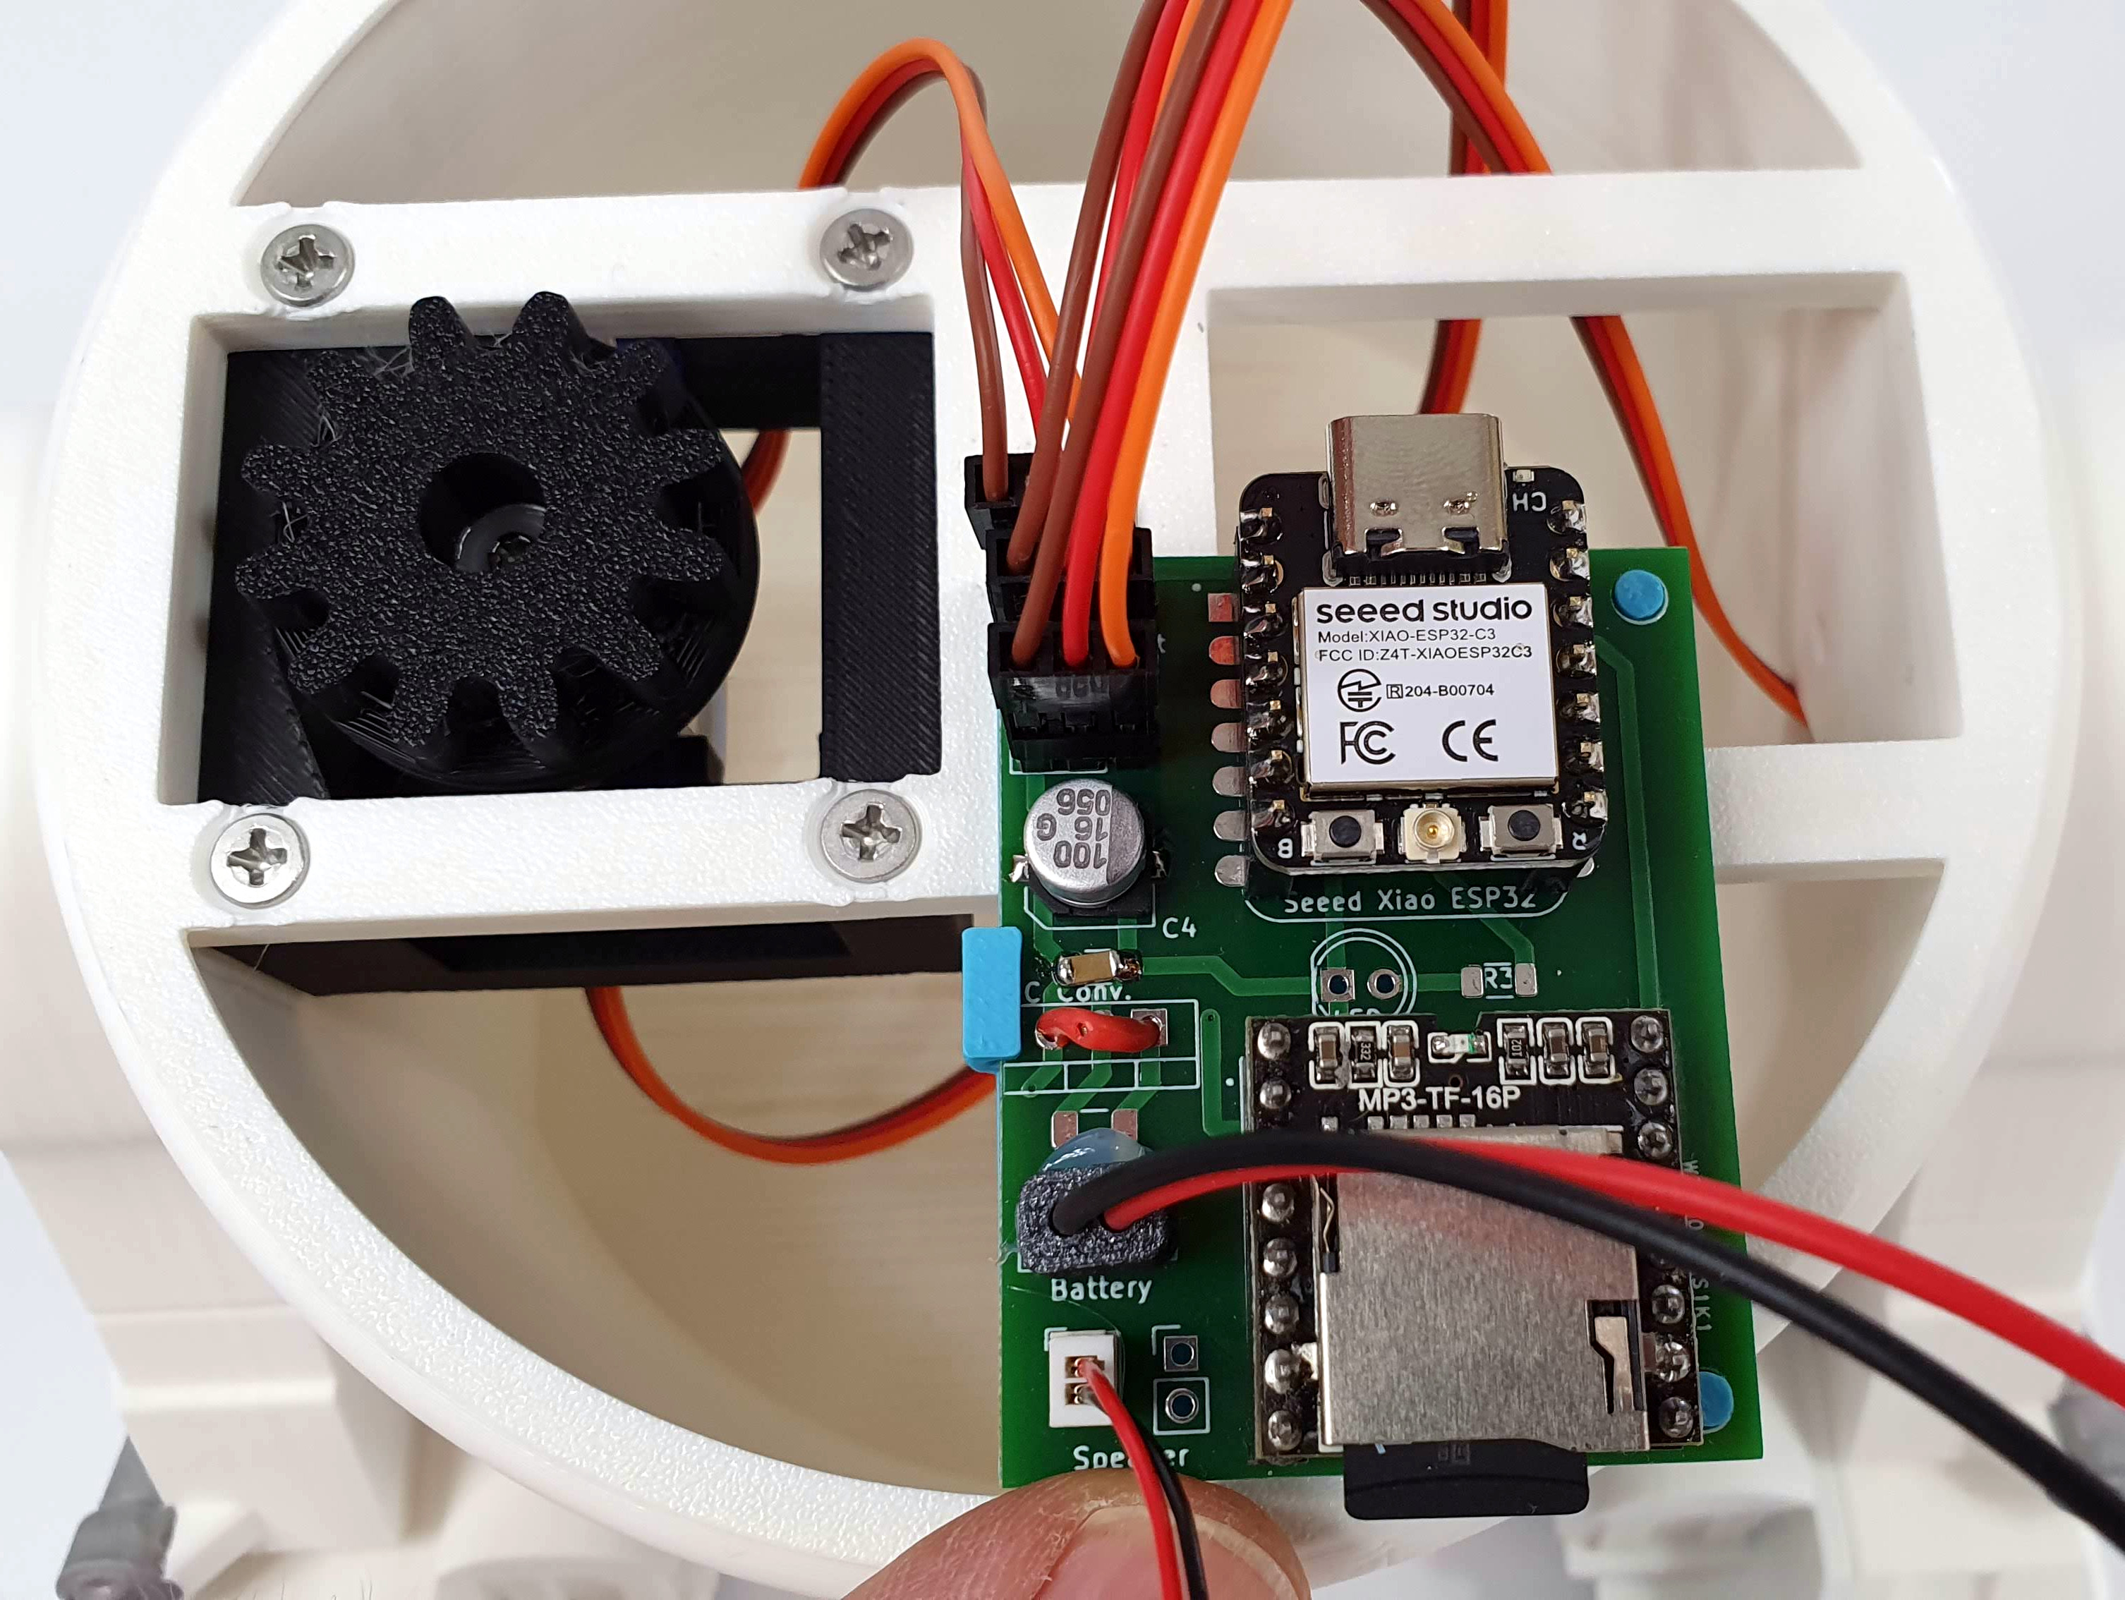
Put all the electronics inside (the main board with connected wires and the speaker).

Ask the instructor to check the electronics connections.
You will receive the droid's battery after correct connection verification.

Improper connection of any element may cause irreversible damage to the electronics.
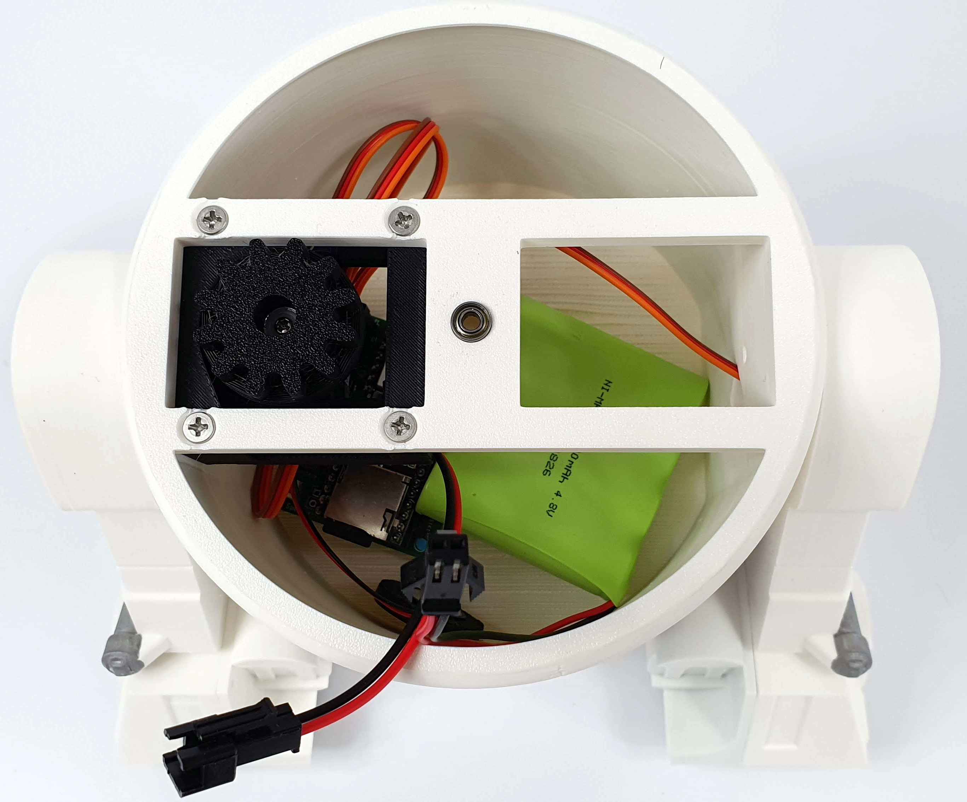
After the workshop leader has checked the correctness of electronics assembly, turn on your smartphone and run the DABBLE application. If you haven't installed it yet, do it now:








After launching the Dabble app, connect the battery to the droid's electronics and place its head on the body. The head axle screw must enter the bearings in the center of the body. If the head does not go all the way in, move it sideways along the axis so that the gears align properly.

The Dabble app requires Bluetooth and Location enabled on your phone. If Dabble asks for location permissions, grant them.

In the Dabble app, connect to your droid. Its Bluetooth device name is written on the top of the carton and should start with BB-DROID-R## where ## is your droid's number.



Select "Gamepad" mode.
The droid's driving is controlled using the arrows on the left. Buttons are used to rotate the head. The remaining buttons trigger different sounds.


